Task on ASG

- Create one VPC in N. Virginia region.
- VPC Dashboard → Create VPC → IPv4 CIDR e.g. 10.0.0.0/16 → Name tag vpc-demo.
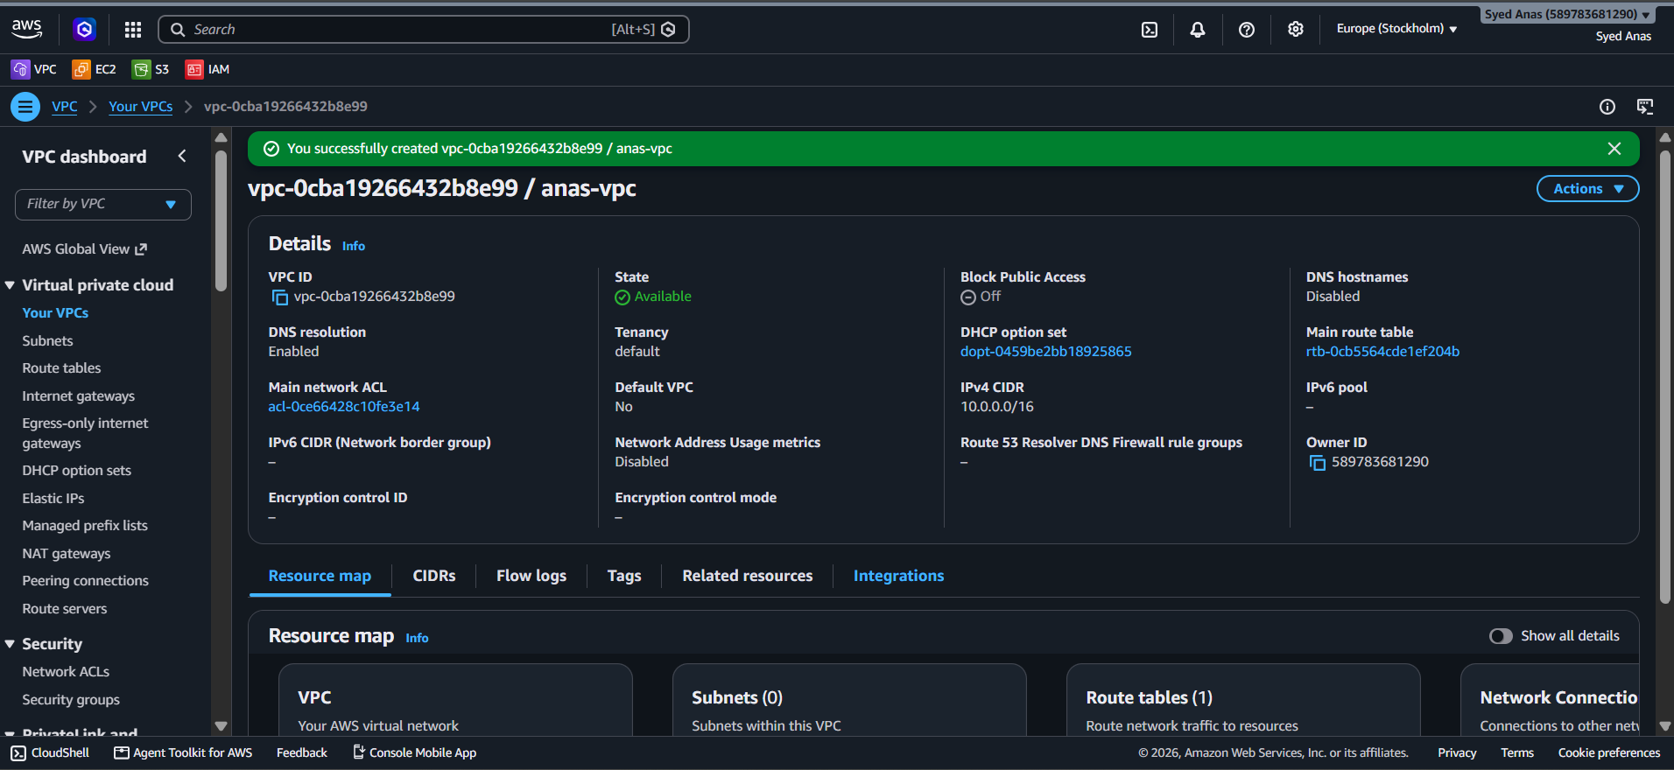

- Create two subnets: one public subnet and one private subnet.
Step 1: Open VPC Dashboard
- Go to AWS Management Console → VPC → Your VPCs.
- Note your VPC ID (you’ll need it for subnet creation).

Step 2: Create Public Subnet
- In the left menu, click Subnets → Create subnet.
- Choose your VPC (My-VPC).
- Under Subnet settings, enter:
  - Subnet name: Public-Subnet
  - Availability Zone: e.g. ap-south-1a
  - IPv4 CIDR block: 10.0.1.0/24
- Click Create subnet.
➡️ You’ve now created the Public Subnet.

Step 3: Enable Auto-assign Public IP
To make it truly public:
- Select the Public Subnet → Click Actions → Edit subnet settings.
- Turn ON the option Auto-assign IP settings → Enable auto-assign public IPv4 address.
- Click Save.

Step 4: Create Private Subnet
- Again go to Subnets → Create subnet.
- Choose the same VPC (My-VPC).
- Under Subnet settings, enter:
  - Subnet name: Private-Subnet
  - Availability Zone: e.g. ap-south-1b
  - IPv4 CIDR block: 10.0.2.0/24
- Click Create subnet.
You now have:
- 10.0.1.0/24 → Public Subnet
- 10.0.2.0/24 → Private Subnet
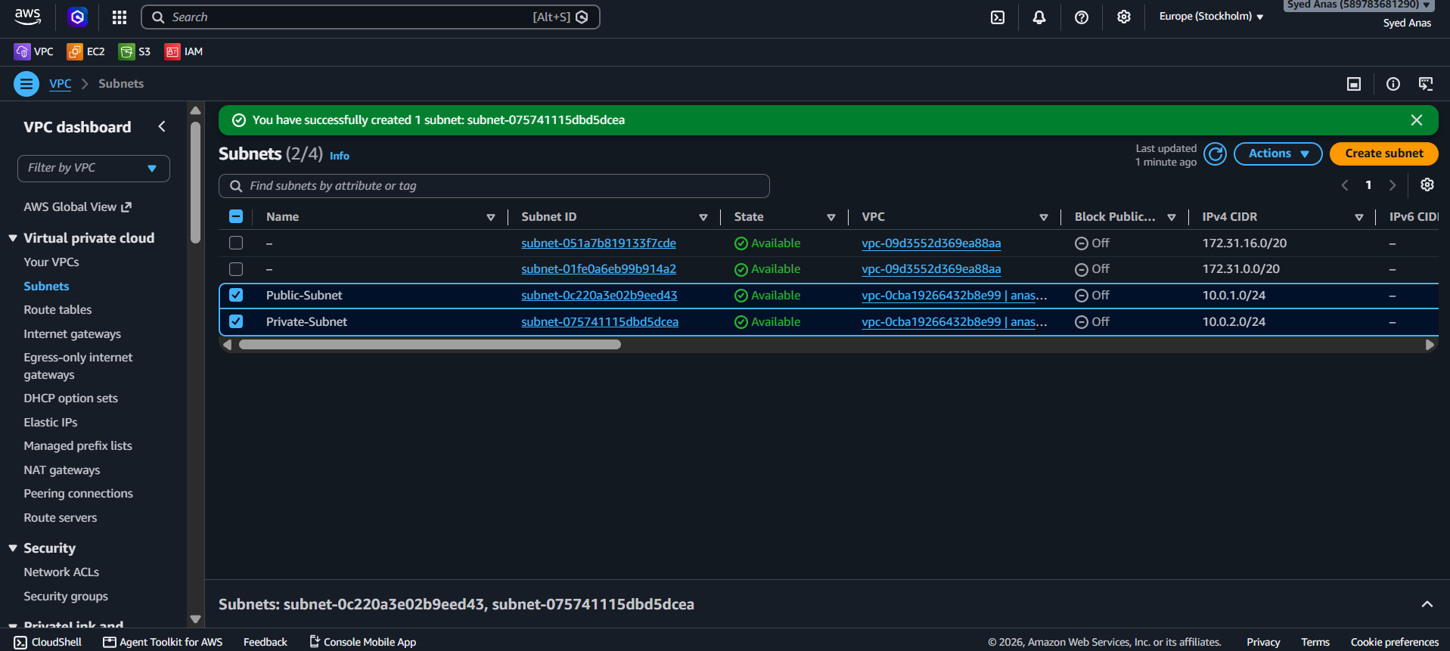
Step 5: Verify
- Go to Subnets → Check both subnets belong to your VPC.
- Confirm the Public Subnet has Auto-assign Public IP enabled.

- Attach an IGW to the VPC.
Step 1: Log in to AWS Console
- Go to the AWS Management Console → VPC service.

Step 2: Create an Internet Gateway (IGW)
- In the left-hand menu, select Internet Gateways.
- Click on Create internet gateway.
- Give it a name (example: MyVPC-IGW).
- Click Create internet gateway.

Step 3: Attach the IGW to your VPC
- Once the IGW is created, select it from the list.
- Click on the Actions dropdown → Attach to VPC.
- Choose your VPC from the list (example: My-VPC).
- Click Attach internet gateway.
✅ Your IGW is now attached to the VPC.

Step 4: (Optional) Verify Attachment
- Go to Internet Gateways → check the VPC ID column.
- It should show your VPC name/ID instead of “Detached”.

Step 5: (Optional) Update Route Table
If you want your instances to access the Internet:
- Go to Route Tables.
- Select the route table associated with your public subnet.
- Click Edit routes → Add route.
- Add:
  - Destination: 0.0.0.0/0
  - Target: Select your Internet Gateway (IGW).
- Click Save changes.
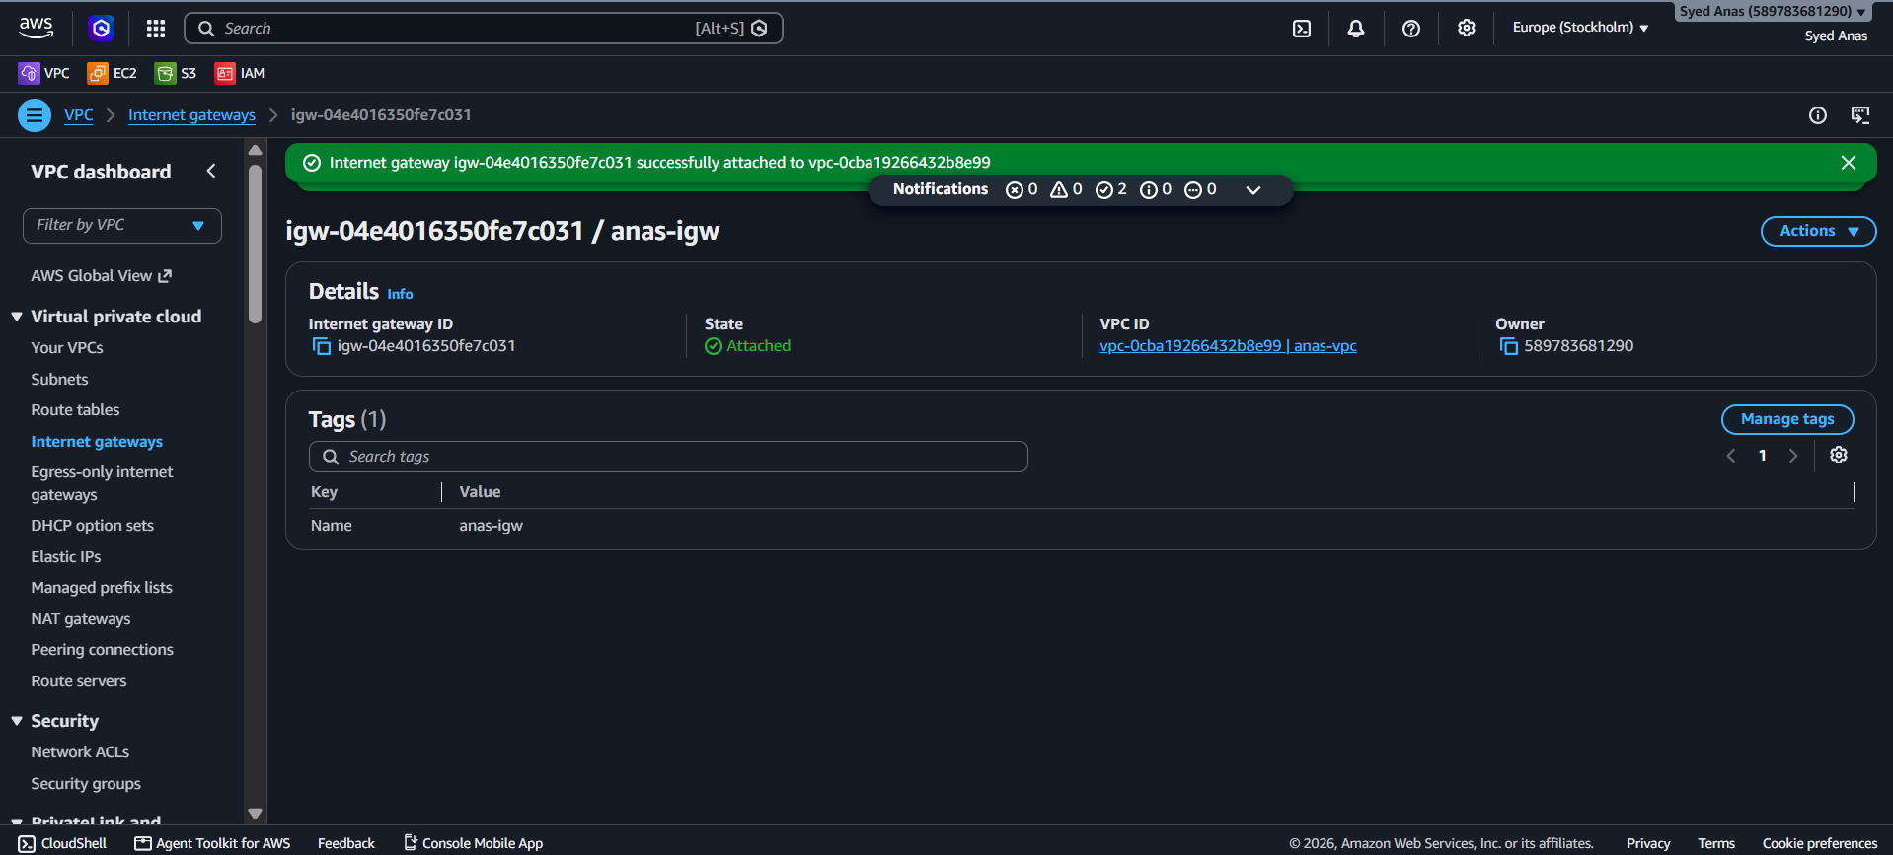
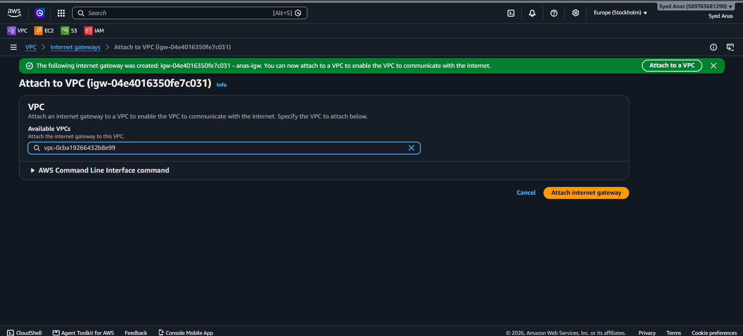

- Create one public route table (RT) and one private route table.
Step 1: Go to VPC Dashboard
- In the AWS Management Console, go to VPC → Route Tables.
- Click Create route table.
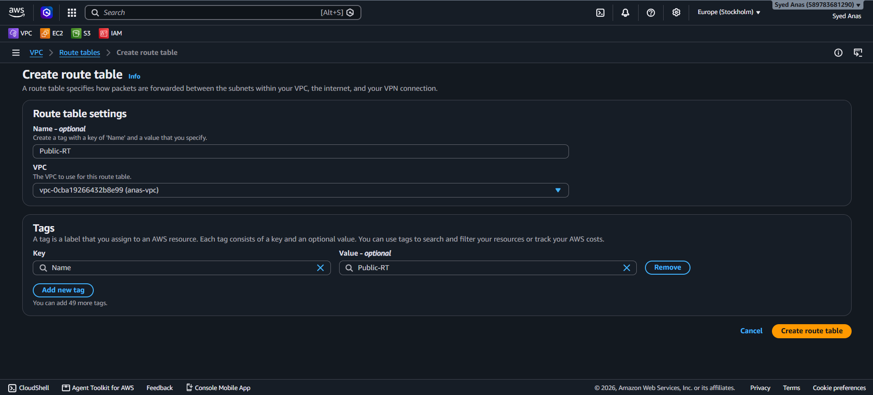
Step 2: Create Public Route Table
- Name tag: Public-RT
- VPC: Select your VPC (e.g., My-VPC).
- Click Create route table.

Step 3: Add Internet Route to Public RT
- Select the Public-RT you just created.
- Go to Routes tab → click Edit routes → Add route.
- Add:
  - Destination: 0.0.0.0/0
  - Target: Select your Internet Gateway (IGW) (the one you attached earlier).
- Click Save changes.
✅ This allows Internet access for instances in the public subnet.

Step 4: Associate Public Subnet
- In Public-RT, go to the Subnet associations tab → click Edit subnet associations.
- Select your Public Subnet (10.0.1.0/24).
- Click Save associations.

Step 5: Create Private Route Table
- Go back to Route Tables → click Create route table again.
- Name tag: Private-RT
- VPC: Select your VPC (e.g., My-VPC).
- Click Create route table.

Step 6: (Optional) Add NAT Gateway Route
If you plan to give outbound Internet access to private instances (for updates, etc.):
- Select Private-RT → Routes → Edit routes → Add route.
- Add:
  - Destination: 0.0.0.0/0
  - Target: Select your NAT Gateway (must be in the Public Subnet).
- Save changes.
Otherwise, leave it as-is — this keeps your private subnet fully isolated.

Step 7: Associate Private Subnet
- In Private-RT, go to Subnet associations tab → Edit subnet associations.
- Select your Private Subnet (10.0.2.0/24).
- Click Save associations.

✅ You now have:
Route Table | Subnet Associated | Internet Route | Access Type
Public-RT | Public Subnet | IGW | Public
Private-RT | Private Subnet | None / NAT Gateway | Private

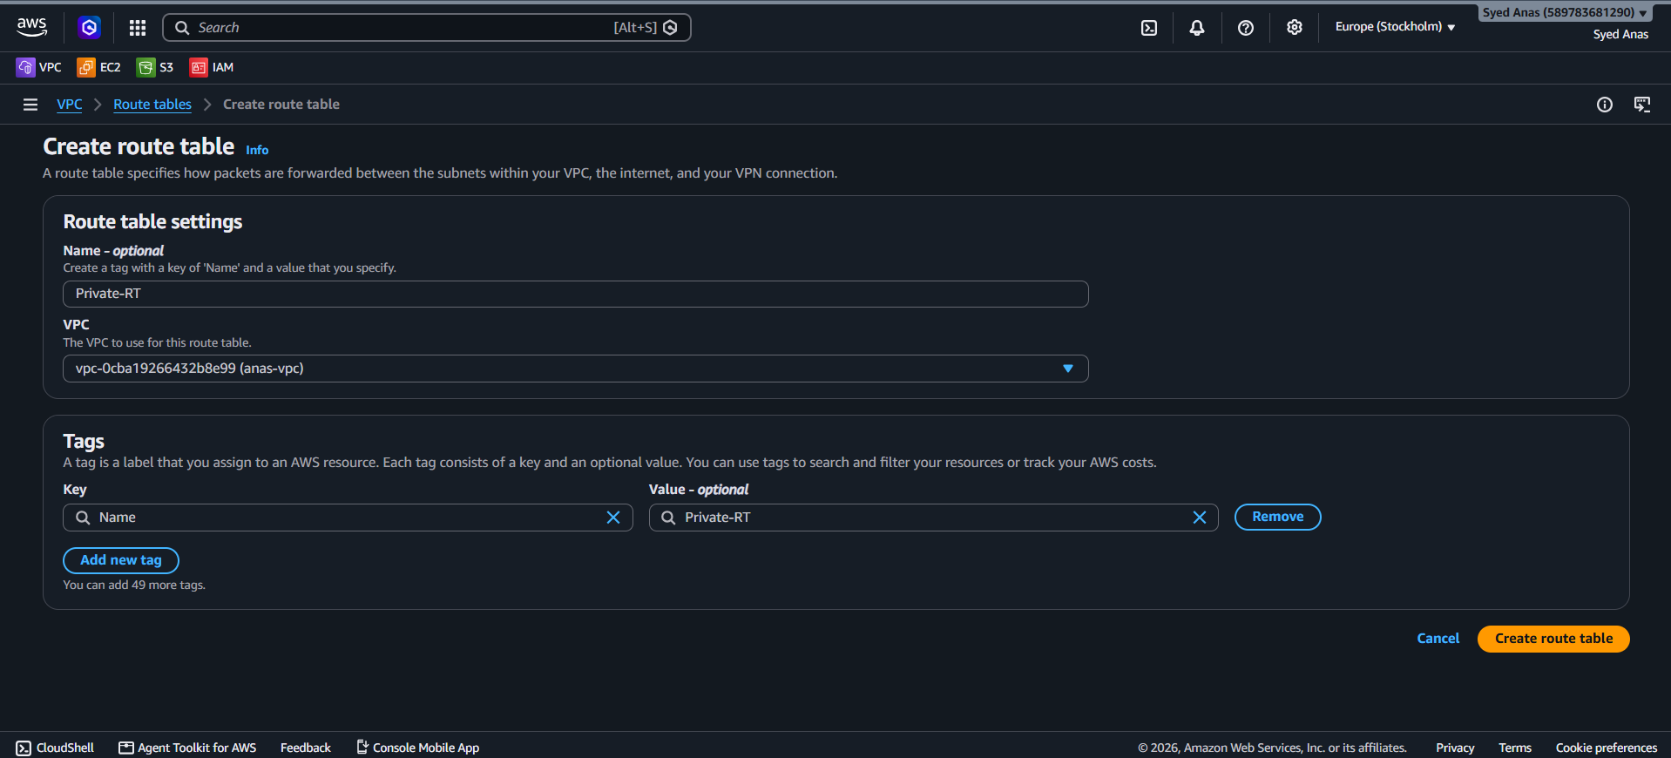

- Deploy a NAT gateway in the public subnet and attach the NAT gateway to the private subnet.
Step 1: Go to VPC Dashboard
- In the AWS Console, navigate to:
Services → VPC → NAT Gateways.

Step 2: Create a NAT Gateway
- Click Create NAT Gateway.
- Enter:
  - Name: My-NAT-Gateway
  - Subnet: Choose your Public Subnet (10.0.1.0/24).
  - Connectivity type: Public (so it can reach the Internet).
- Under Elastic IP allocation, click Allocate Elastic IP (AWS will assign a public IP to the NAT Gateway).
- Click Create NAT Gateway.
🕒 Wait for status to change from Pending → Available (takes 1–2 minutes).

Step 3: Update the Private Route Table
- Go to VPC → Route Tables.
- Select your Private Route Table (e.g., Private-RT).
- Go to Routes → Edit routes → Add route.
- Enter:
  - Destination: 0.0.0.0/0
  - Target: Select your NAT Gateway (e.g., nat-0abcd1234efgh5678).
- Click Save changes.
✅ Now, any outbound Internet traffic from instances in the private subnet will go through the NAT Gateway.

Step 4: Verify
- Launch one EC2 instance in Public Subnet (for SSH access).
- Launch another in Private Subnet (without public IP).
- From the Public instance, SSH into the Private instance (using private IP).
- On the Private instance, try:
- ping google.com
or
sudo yum update -y
✅ If you get responses, your NAT Gateway setup is working perfectly.
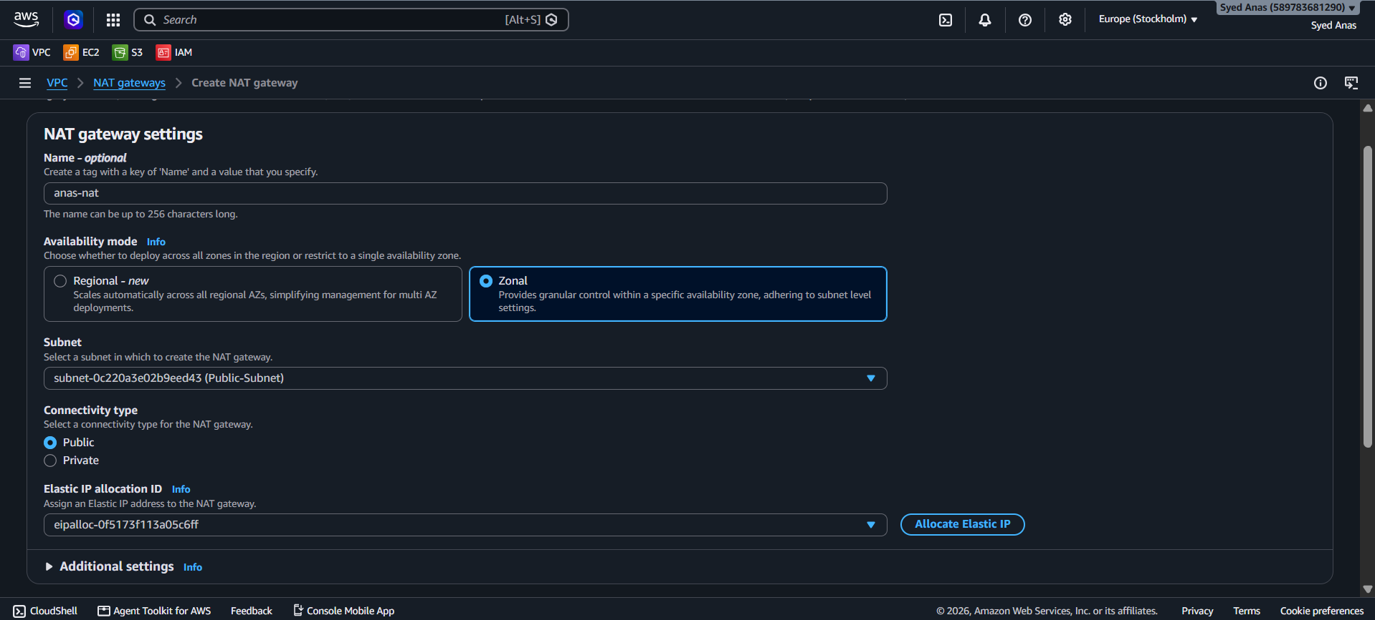

- Create two instances, one in the public subnet and one in the private subnet.
Step 1: Go to EC2 Dashboard
- In the AWS Console, open EC2 → Instances → Launch instance.

Step 2: Create Public Instance
- Name: Public-Instance
- AMI: Amazon Linux 2 (or Ubuntu 22.04)
- Instance Type: t2.micro (Free tier eligible)
- Key pair: Select or create a key pair for SSH access.
- Network Settings:
  - VPC: Choose your custom VPC (My-VPC)
  - Subnet: Select Public Subnet (10.0.1.0/24)
  - Auto-assign Public IP: Enable
- Security Group:
  - Create a new one or use existing:
    - Inbound rule: SSH (port 22) → Source: 0.0.0.0/0
- Click Launch instance.
✅ Result:
Your Public EC2 instance will have a public IPv4 address and is reachable via SSH.

Step 3: Create Private Instance
- Name: Private-Instance
- AMI: Same as Public (Amazon Linux 2 / Ubuntu)
- Instance Type: t2.micro
- Key pair: Use the same key pair as the public one (for SSH tunneling).
- Network Settings:
  - VPC: Select your same VPC.
  - Subnet: Select Private Subnet (10.0.2.0/24)
  - Auto-assign Public IP: Disable (default for private subnets)
- Security Group:
  - Create a new one allowing:
    - Inbound: SSH (22) → Source: The Private IP or Security Group of the Public Instance
- Click Launch instance.
✅ Result:
Your Private instance has no public IP and cannot be reached from the Internet directly.

Step 4: Connect to Instances
(A) Connect to Public Instance
From your terminal:
ssh -i mykey.pem ec2-user@<Public-IP-of-Public-Instance>

(B) Connect to Private Instance (via Public Instance)
Once inside the Public Instance, connect to the Private one:
ssh ec2-user@<Private-IP-of-Private-Instance>

💡 Tip: Ensure both instances use the same key pair so SSH can work seamlessly.

Step 5: Test NAT Gateway Internet Access
From inside the Private Instance, run:
ping google.com
or
sudo yum update -y

✅ If packets or updates download successfully — your NAT Gateway setup works perfectly.
If not:
- Check if Private RT has 0.0.0.0/0 → NAT Gateway route.
- Ensure the NAT Gateway is in the Public Subnet and Available.
- Verify Public Subnet route table → 0.0.0.0/0 → IGW.

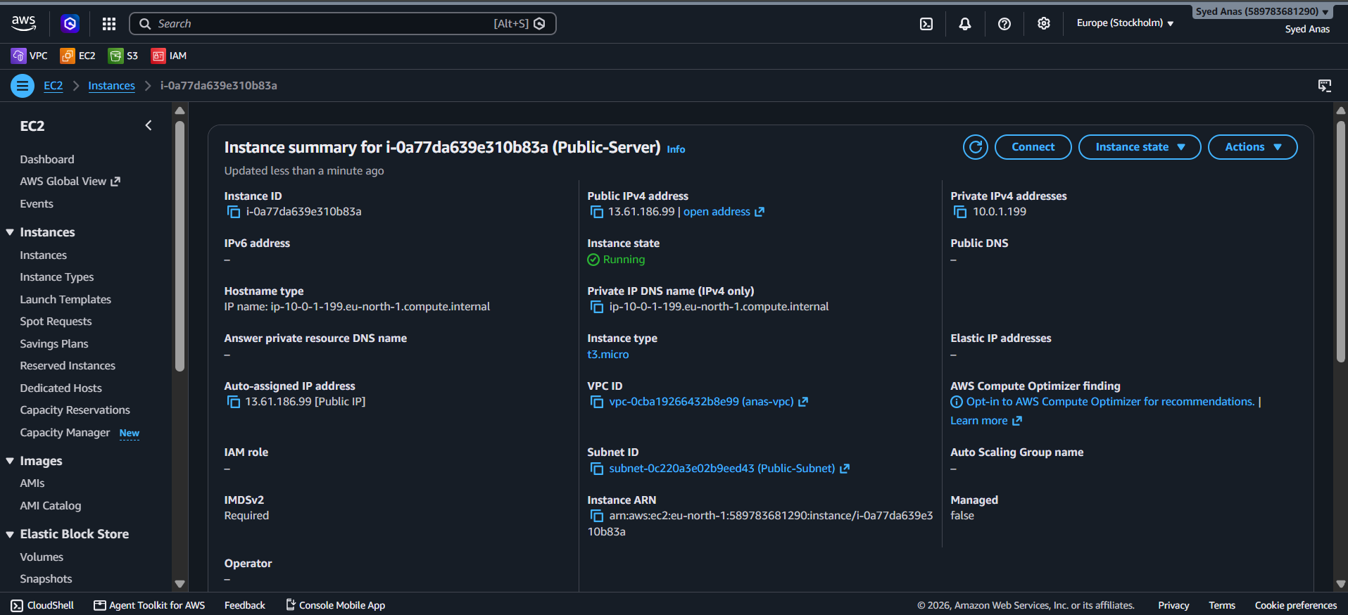

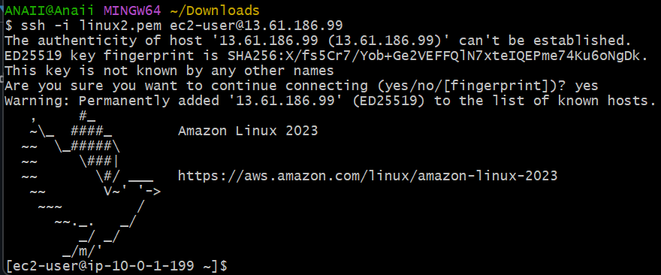

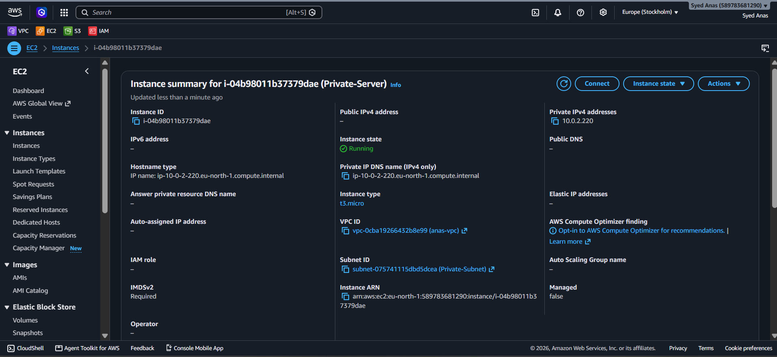

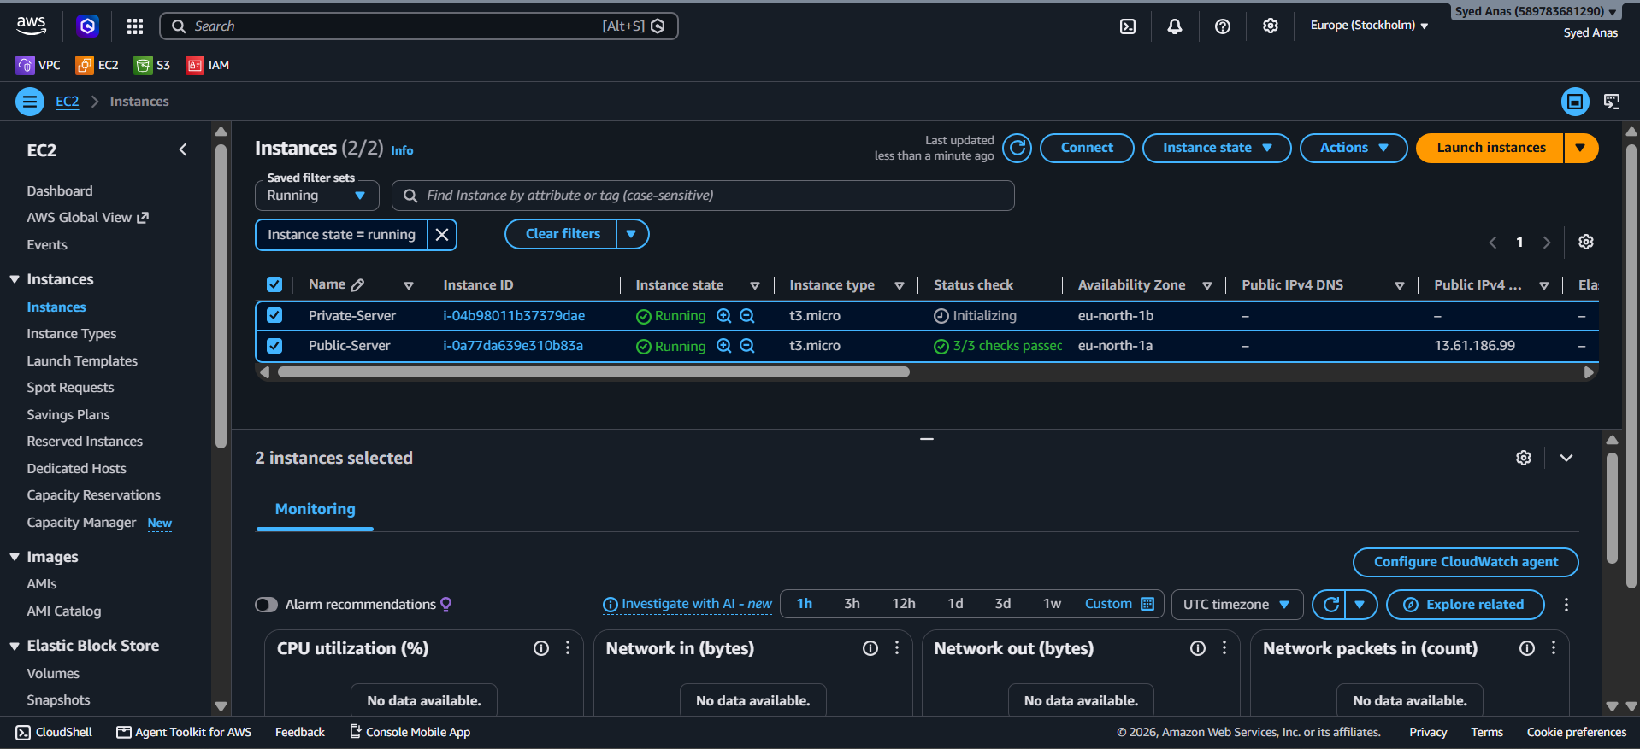
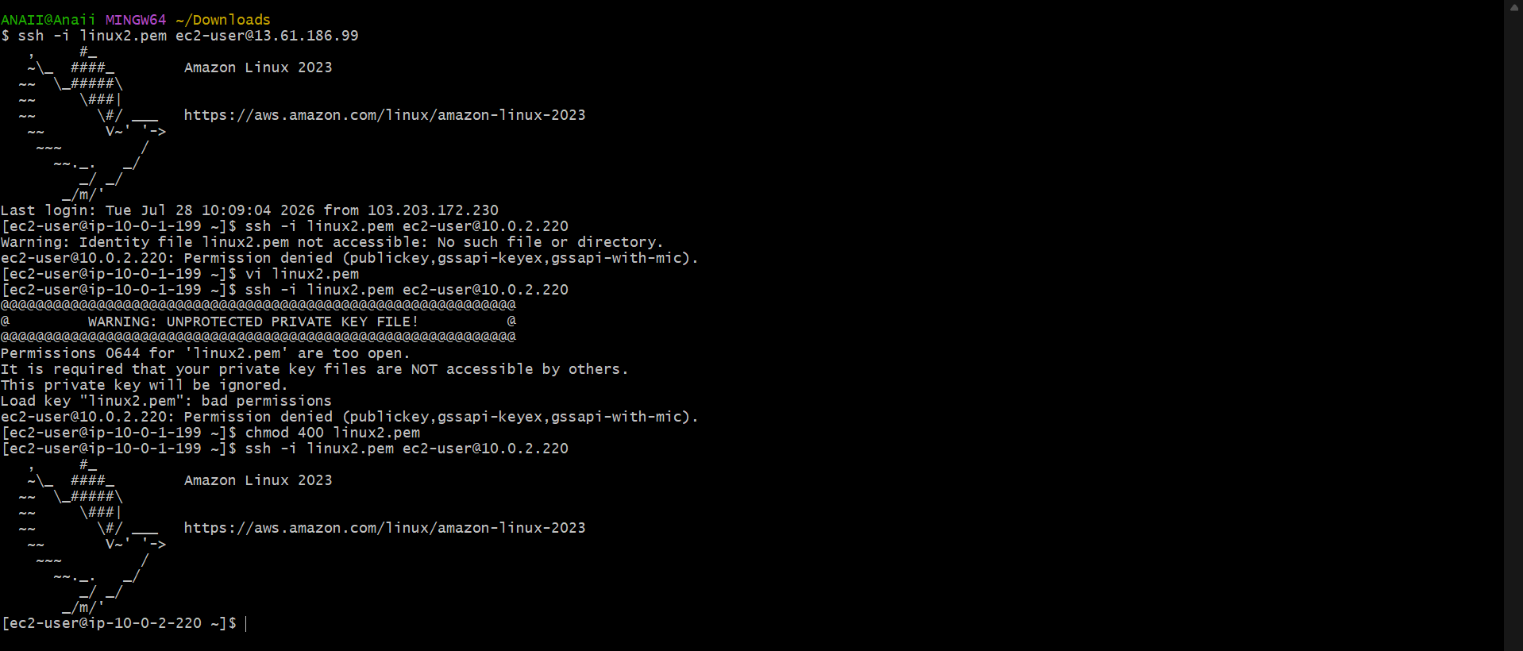

- Deploy Apache server on both EC2 instances with a sample index.html file.
Step 1: Connect to the Instances
- Connect to the Public EC2
From your local machine:
ssh -i mykey.pem ec2-user@<Public-IP>
- (B) Connect to the Private EC2
Once logged into the Public instance:
ssh ec2-user@<Private-IP>
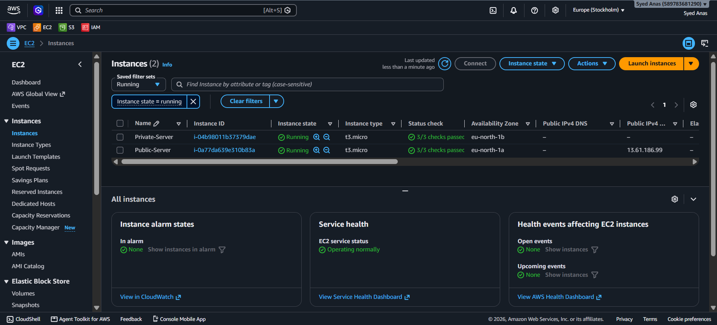
Step 2: Update Packages
On both instances (run separately):
sudo yum update -y
💡 The private instance will use the NAT Gateway for Internet access here — this step confirms NAT is working correctly.

Step 3: Install Apache Web Server
sudo yum install -y httpd
For Ubuntu, use:
sudo apt update -y
sudo apt install -y apache2

Step 4: Start and Enable Apache
sudo systemctl start httpd
sudo systemctl enable httpd
(Ubuntu command)
sudo systemctl start apache2
sudo systemctl enable apache2
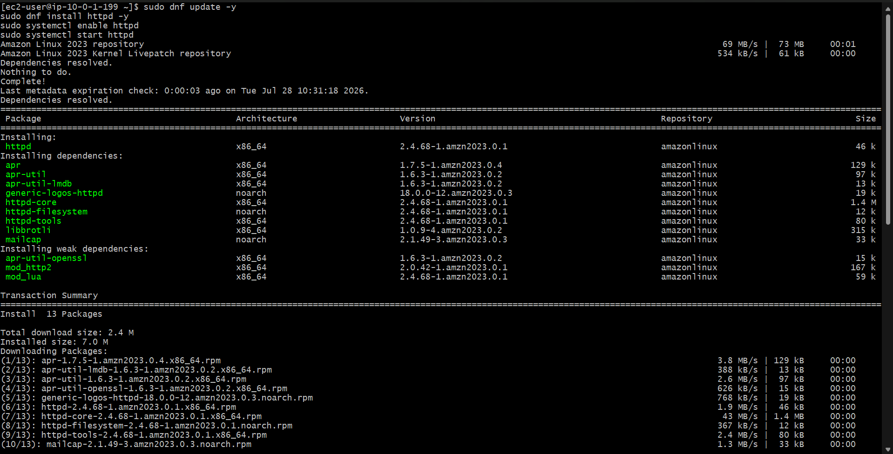
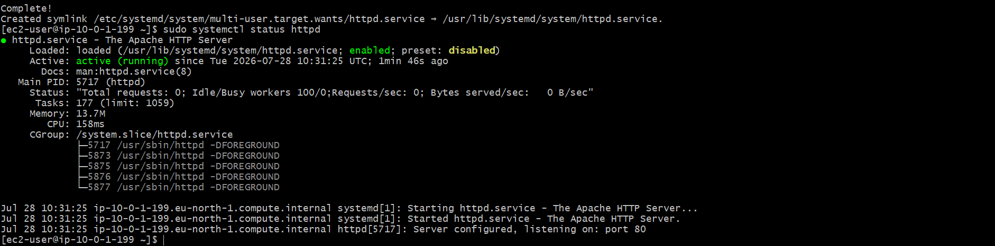
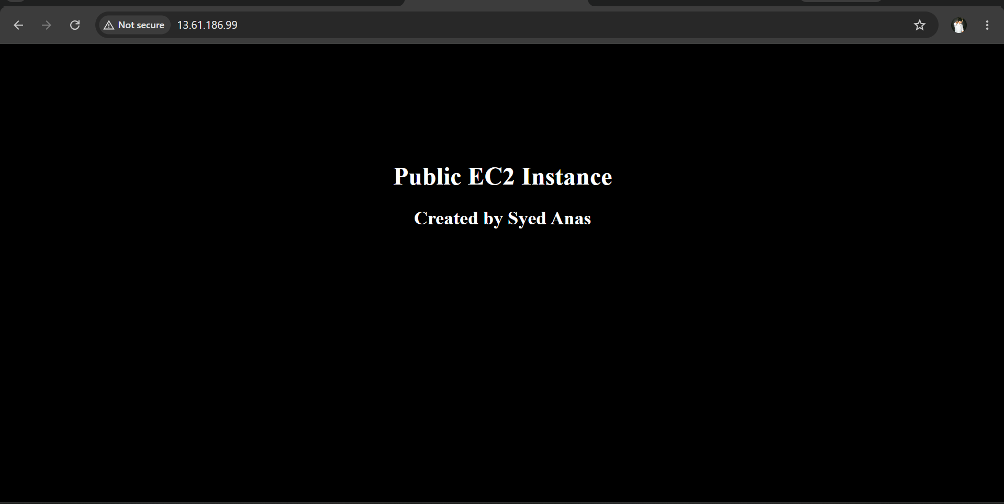
Step 5: Create a Sample index.html Page
Replace the default Apache home page with a custom one.
On Public EC2
echo "<h1>Welcome to the Public Server</h1><p>Hosted in the Public Subnet</p>" | sudo tee /var/www/html/index.html
On Private EC2
echo "<h1>Welcome to the Private Server</h1><p>Hosted in the Private Subnet</p>" | sudo tee /var/www/html/index.html

Step 6: Verify Apache Service
Check if Apache is running:
sudo systemctl status httpd
✅ You should see active (running).

Step 7: Test Access
(A) Public EC2:
From your local browser, go to:
http://<Public-IP>
You should see:
“Welcome to the Public Server”
If not, ensure:
- Security Group allows Inbound Port 80 (HTTP) from 0.0.0.0/0.
(B) Private EC2:
Since it has no public IP, you can test it from within the Public EC2:
curl http://<Private-IP>
Expected output:
<h1>Welcome to the Private Server</h1><p>Hosted in the Private Subnet</p>
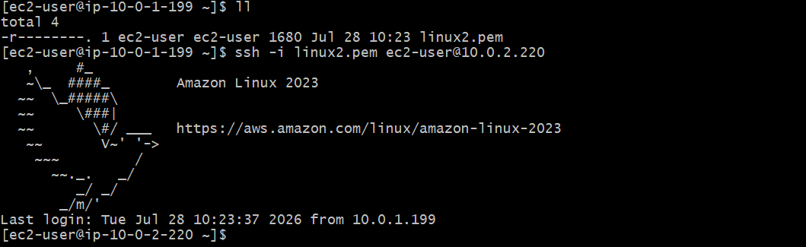
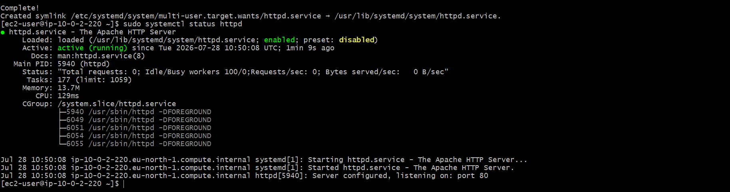


✅ If you see this, the private network routing and Apache setup are both working.

- Create one application load balancer and attach it to both EC2 instances.
Step 1: Create a Target Group
- Go to EC2 Console → Load Balancing → Target Groups → Create target group.
- Choose Target type = “Instances”.
- Set Target group name = web-target-group.
- Protocol = HTTP
Port = 80
VPC = Select your existing VPC.
- Health checks
  - Protocol: HTTP
  - Path: / (or /index.html if you have it)
- Click Next.
✅ Register Targets:
- Select your two EC2 instances.
- Click Include as pending below.
- Click Create target group.

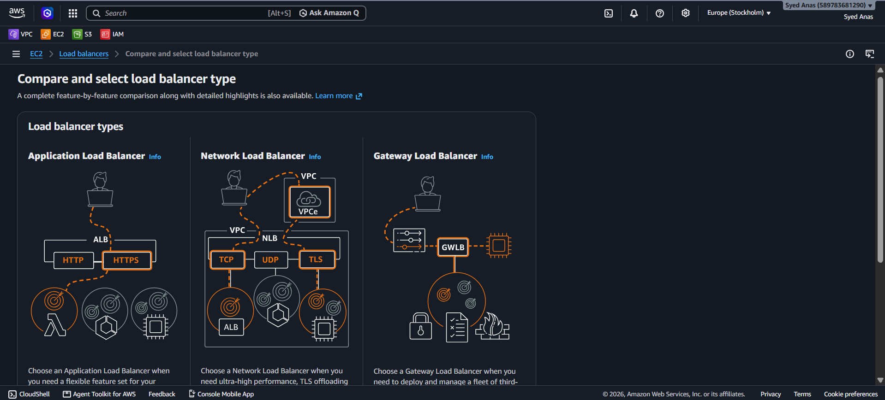

Step 2: Create Application Load Balancer (ALB)
- Go to EC2 Console → Load Balancers → Create Load Balancer.
- Choose Application Load Balancer → click Create.
- Name = my-app-alb
- Scheme = Internet-facing (if you want it public)
OR
Internal (if for private network)
- IP address type = IPv4
- Network mapping
  - Select your VPC.
  - Choose at least two subnets in different AZs.
- Security Groups
  - Create or select a security group that allows HTTP (port 80) inbound.
- Listeners and routing
  - Protocol: HTTP
  - Port: 80
  - Forward to target group → select your web-target-group.
Click Create load balancer ✅

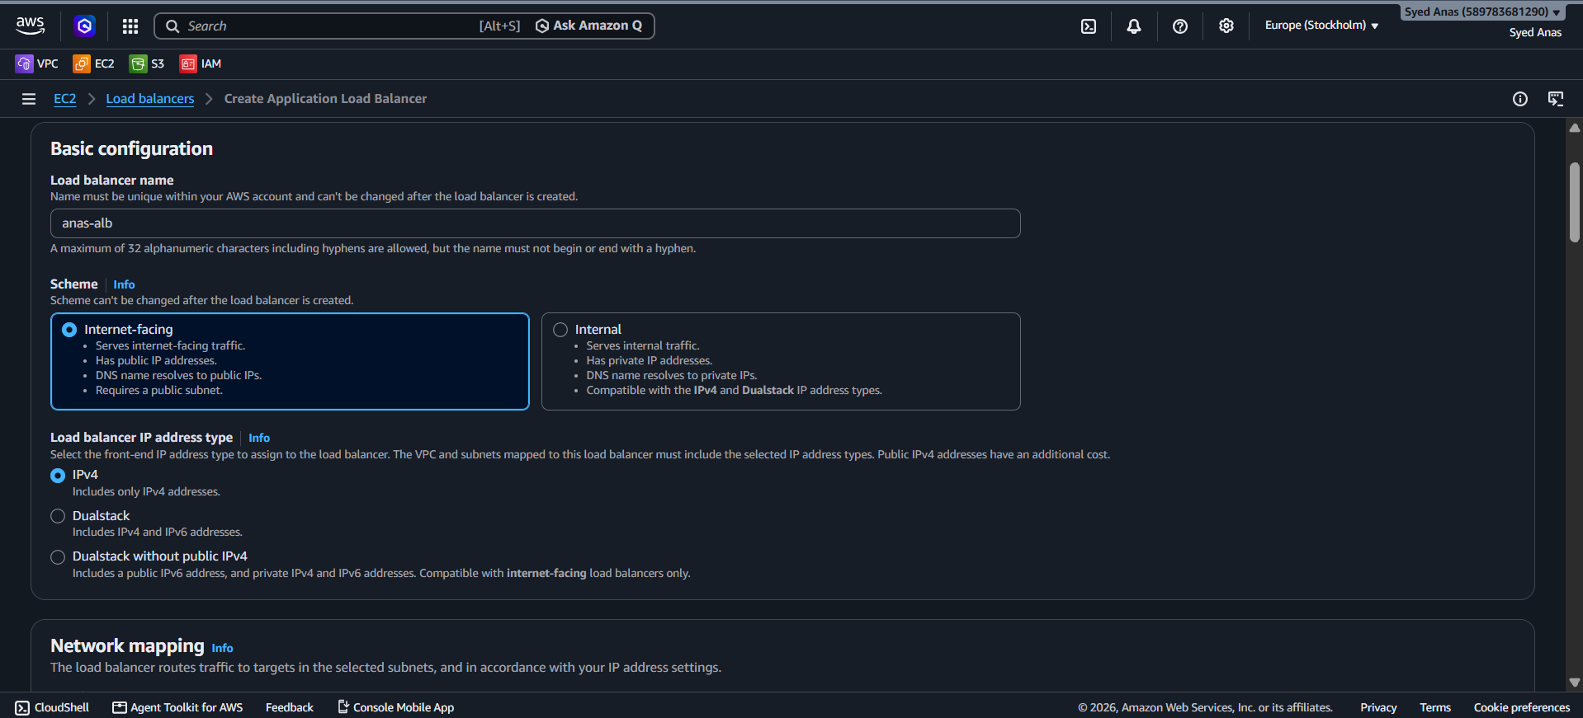
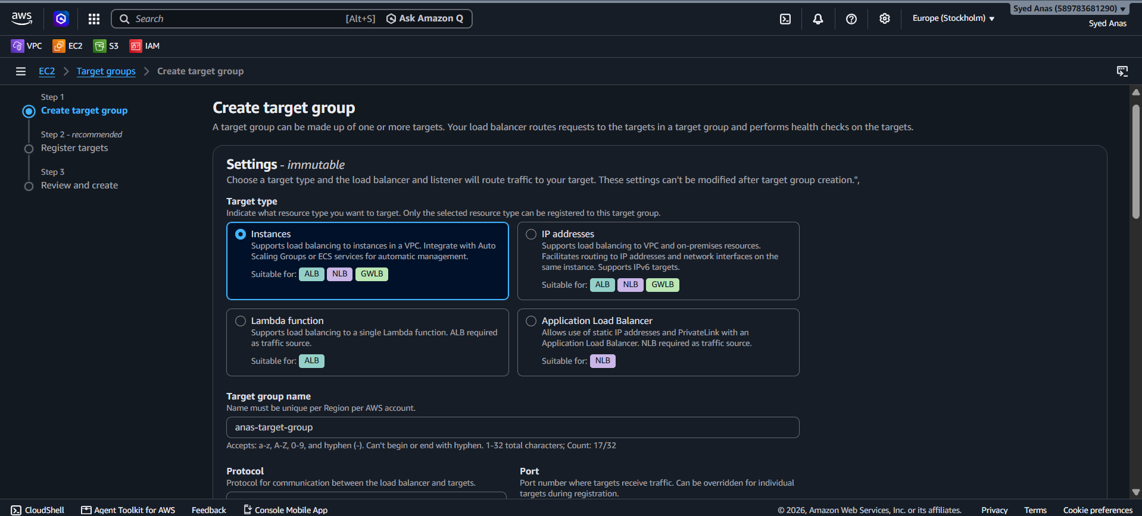
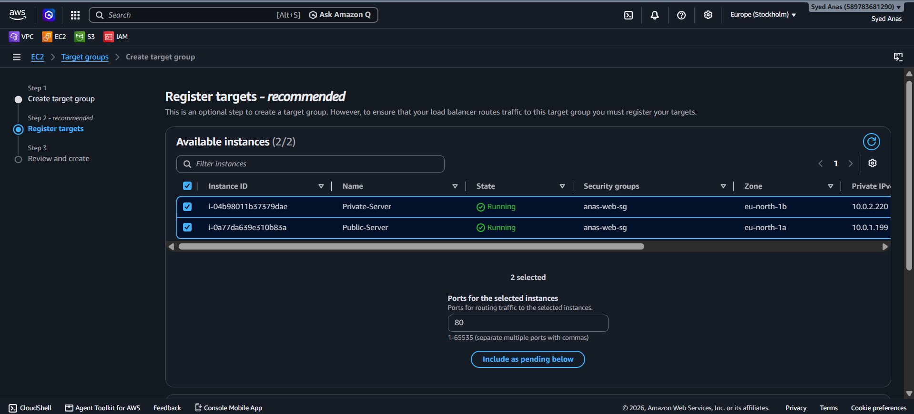

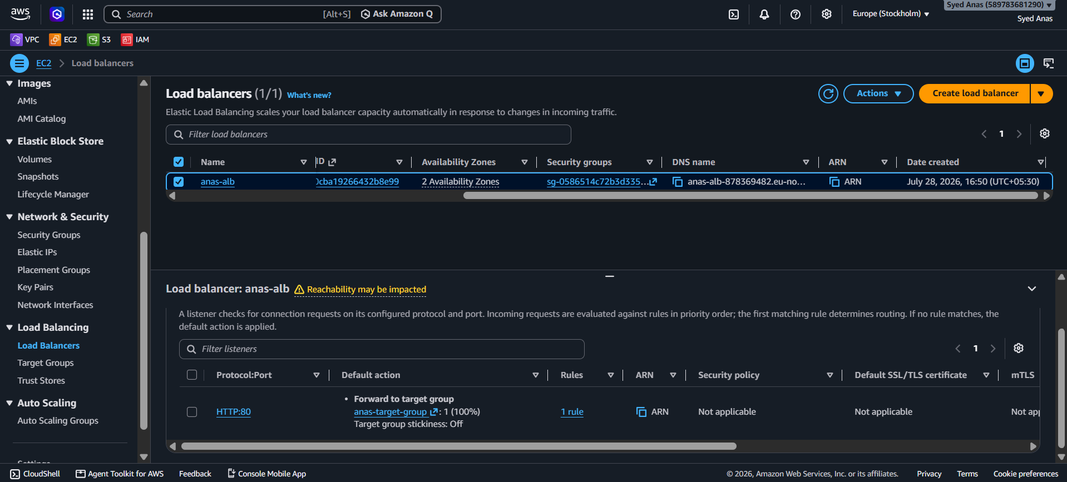

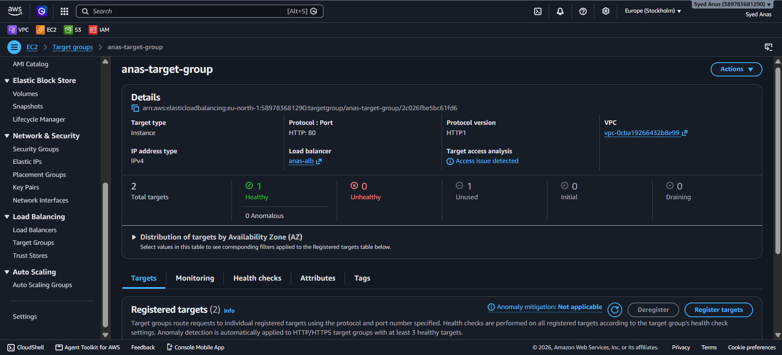

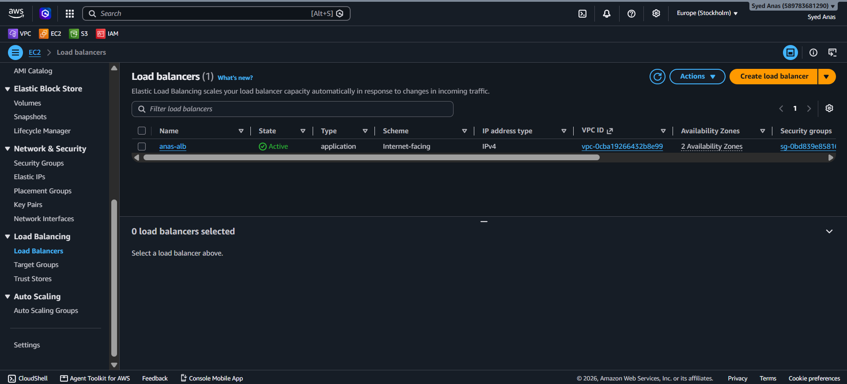
Step 3: Verify ALB Creation
After few minutes, you’ll see:
- Load balancer status: Active
- Target group health: healthy (after health check passes)
Step 4: Test the Setup
- Copy the DNS name of your Load Balancer (example:
my-app-alb-123456789.ap-south-1.elb.amazonaws.com)
- Paste it into your browser.

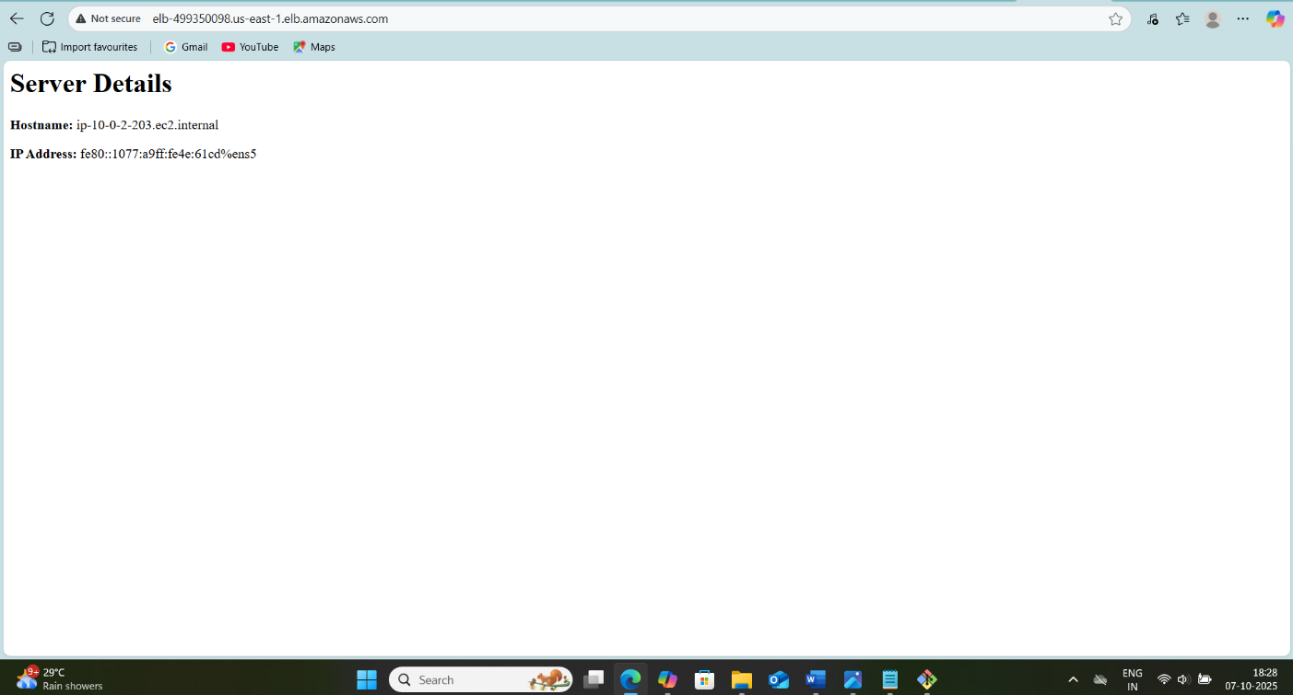

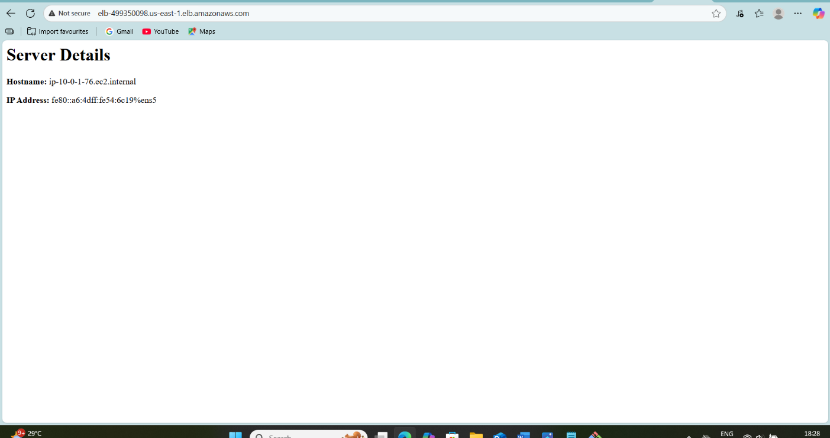
You should see the Apache default page or your custom index.html file.
If you refresh multiple times, the load balancer will distribute requests between your EC2 instances (round-robin).

🔒 Security Group Configuration
Resource | Inbound Rule | Outbound Rule
Load Balancer SG | HTTP (80) from 0.0.0.0/0 | All traffic
EC2 SG | HTTP (80) from Load Balancer SG | All traffic
This ensures only ALB can reach EC2 instances securely.

- Store application load balancer logs in S3.
Step 1: Prerequisites
Before enabling ALB logging, make sure:
- You already have:
  - An Application Load Balancer (ALB) created.
  - At least one Target Group and EC2 instance registered.
  - ALB is running and receiving traffic.
- You have S3 bucket ready or you can create one (we’ll create it next).

Step 2: Create an S3 Bucket for ALB Logs
- Using AWS Console
- Go to S3 Service → Create bucket.
- Enter a unique bucket name, for example:
- my-alb-access-logs-bucket
- Choose the region where your ALB is located (recommended same region).
- Uncheck “Block all public access” (optional — only if you need to analyze via Athena or another service later).
- Click Create bucket.

✅ Using AWS CLI
aws s3api create-bucket --bucket my-alb-access-logs-bucket --region ap-south-1

Step 3: Give ALB Permission to Write Logs to S3
By default, the ALB service needs permission to store logs in your bucket.
✅ Attach Bucket Policy
- Go to S3 → your bucket → Permissions tab → Bucket Policy.
- Paste and modify this policy (replace REGION, ACCOUNT_ID, and BUCKET_NAME):
{
"Version": "2012-10-17",
"Statement": [
{
"Sid": "AWSLoadBalancerLogsPolicy",
"Effect": "Allow",
"Principal": {
"Service": "logdelivery.elasticloadbalancing.amazonaws.com"
},
"Action": "s3:PutObject",
"Resource": "arn:aws:s3:::my-alb-access-logs-bucket/AWSLogs/123456789012/*"
}
]
}
🔹 Replace:
- my-alb-access-logs-bucket → your bucket name
- 123456789012 → your AWS account ID
- Click Save changes.

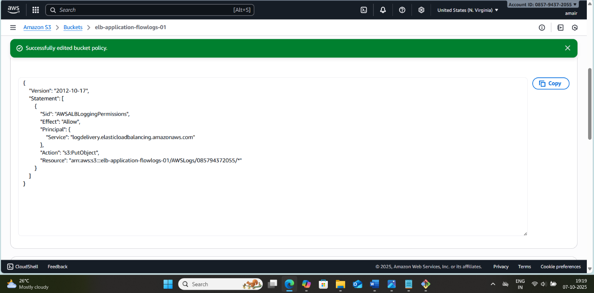
Step 4: Enable Access Logging in ALB
- Using AWS Console
- Open EC2 → Load Balancers → Select your ALB.
- Go to the Attributes tab.
- Under Access logs, click Edit.
- Check Enable access logs.
- Choose your S3 bucket (my-alb-access-logs-bucket).
- Optionally, specify a prefix/folder (e.g., alb-logs/).
- Click Save changes.

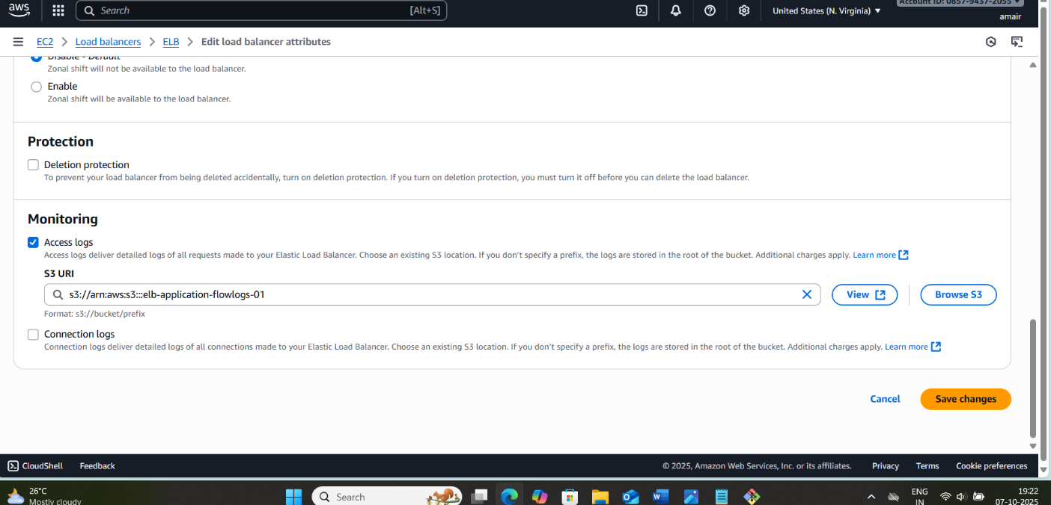
✅ Now the ALB will start sending log files to S3 automatically.
- Using AWS CLI
aws elbv2 modify-load-balancer-attributes \
--load-balancer-arn arn:aws:elasticloadbalancing:ap-south-1:123456789012:loadbalancer/app/my-alb/50dc6c495c0c9188 \
--attributes Key=access_logs.s3.enabled,Value=true Key=access_logs.s3.bucket,Value=my-alb-access-logs-bucket Key=access_logs.s3.prefix,Value=alb-logs

Step 5: Verify Logs in S3
After a few minutes of traffic (requests hitting your ALB):
- Go to S3 → your bucket → alb-logs/.
- You’ll see folders like:
- AWSLogs/123456789012/elasticloadbalancing/ap-south-1/2025/10/13/
- Inside, you’ll find log files like:
- my-alb-app-20251013T1055Z-1a2b3c4d5e6f7g8h.log.gz
- You can download or analyze them using:
  - AWS Athena
  - AWS Glue
  - CloudWatch Insights
  - Custom scripts

- 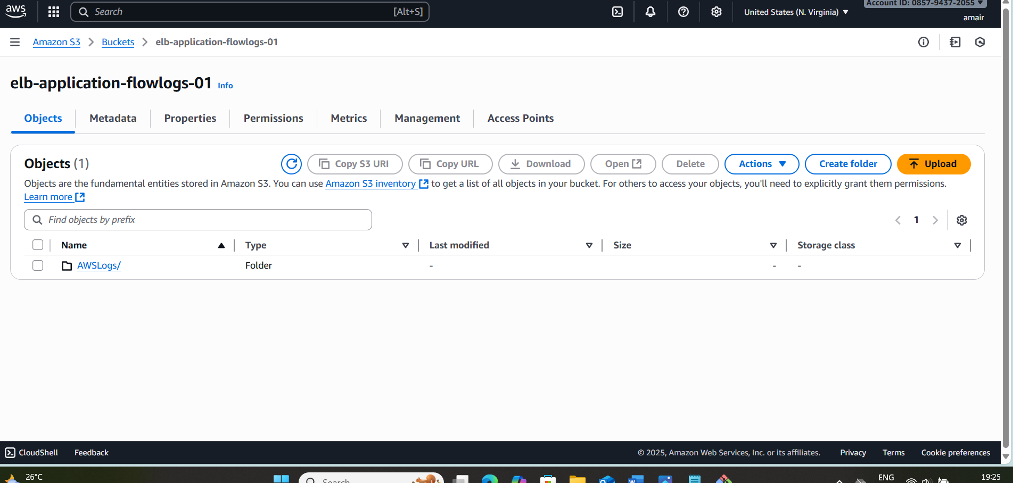
Step 6: (Optional) Query Logs with Athena
You can create an Athena table to analyze ALB logs directly.
Example Athena DDL:
CREATE EXTERNAL TABLE alb_logs (
type string,
time string,
elb string,
client_ip string,
target_ip string,
request_processing_time double,
target_processing_time double,
response_processing_time double,
elb_status_code int,
target_status_code int,
received_bytes bigint,
sent_bytes bigint,
request_verb string,
request_url string,
request_proto string,
user_agent string,
ssl_cipher string,
ssl_protocol string
)
ROW FORMAT SERDE 'org.apache.hadoop.hive.serde2.lazy.LazySimpleSerDe'
WITH SERDEPROPERTIES (
'separatorChar' = ' ',
'escapeChar' = '\\'
)
LOCATION 's3://my-alb-access-logs-bucket/AWSLogs/123456789012/elasticloadbalancing/ap-south-1/';
- Use CloudWatch Logs Insights
- Go to CloudWatch → Logs Insights → Select log group.
- Example query for ALB logs:
fields @timestamp, client_ip, request_url, elb_status_code
| filter elb_status_code >= 400
| stats count() by elb_status_code
| sort count() desc
- This query shows error responses (4xx, 5xx) with their counts.
- You can also create dashboards with graphs and alerts.

- Set Alerts (Optional)
- Use CloudWatch Alarms:
  - Monitor high error rates.
  - Trigger SNS notifications to email or Slack.

✅ Final Verification
- Traffic is going through the ALB.
- Logs are being stored in the S3 bucket.
- S3 bucket policy allows ELB to write logs.
- Files are visible under AWSLogs/… path.

- Store the VPC flow logs in a CloudWatch log group.
Step 1: Understand VPC Flow Logs
VPC Flow Logs capture information about the IP traffic going to and from network interfaces in your VPC. This is useful for monitoring, security analysis, and troubleshooting.
You can store VPC Flow Logs in CloudWatch Logs or S3. Here, we are storing them in CloudWatch.

Step 2: Prerequisites
- You need a VPC already created.
- IAM role or permissions to create VPC flow logs and write to CloudWatch Logs.
  - Policy should include logs:CreateLogGroup, logs:CreateLogStream, logs:PutLogEvents.
- CloudWatch Log Group (you can create it during the VPC Flow Log creation).

Step 3: Create a CloudWatch Log Group
You can either pre-create a log group or let AWS create it automatically.
- AWS Console:
  - Open CloudWatch → Logs → Create log group.
  - Give it a name, e.g., /vpc/flowlogs.
  - Choose retention period (e.g., 1 month, 3 months).

- AWS CLI:
aws logs create-log-group --log-group-name /vpc/flowlogs

Step 4: Create a VPC Flow Log
You can create a flow log for a VPC, a subnet, or a network interface.
- AWS Console:
  - Go to VPC Dashboard → Your VPCs.
  - Select your VPC → Actions → Create flow log.
  - Configure the following:
    - Filter: All, Accept, or Reject (choose All for complete logging).
    - Destination: Send to CloudWatch Logs.
    - Log group: Select the log group you created (/vpc/flowlogs).
    - IAM role: AWS will prompt to create a new role or use existing.
  - Click Create Flow Log.
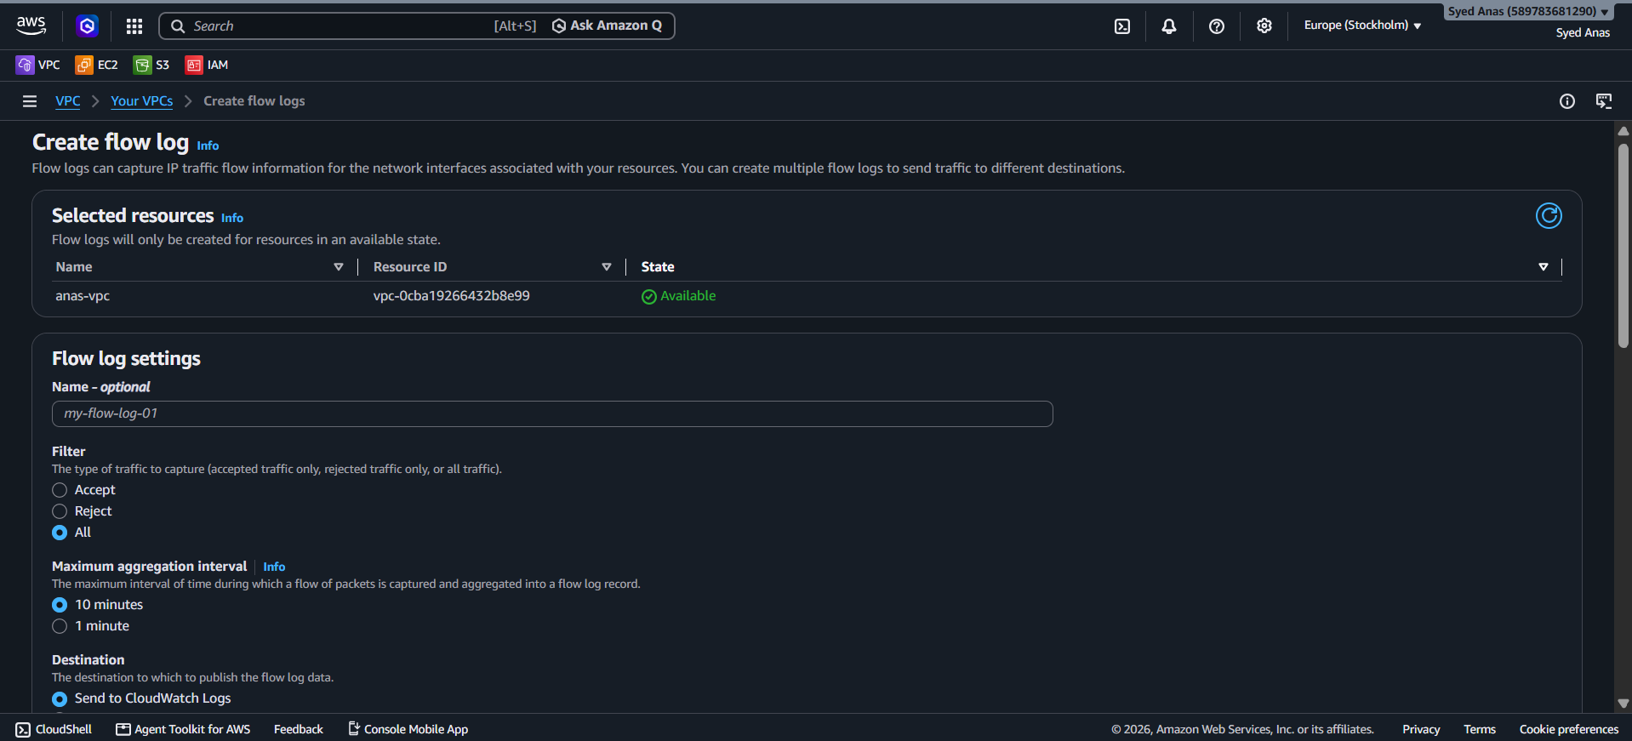

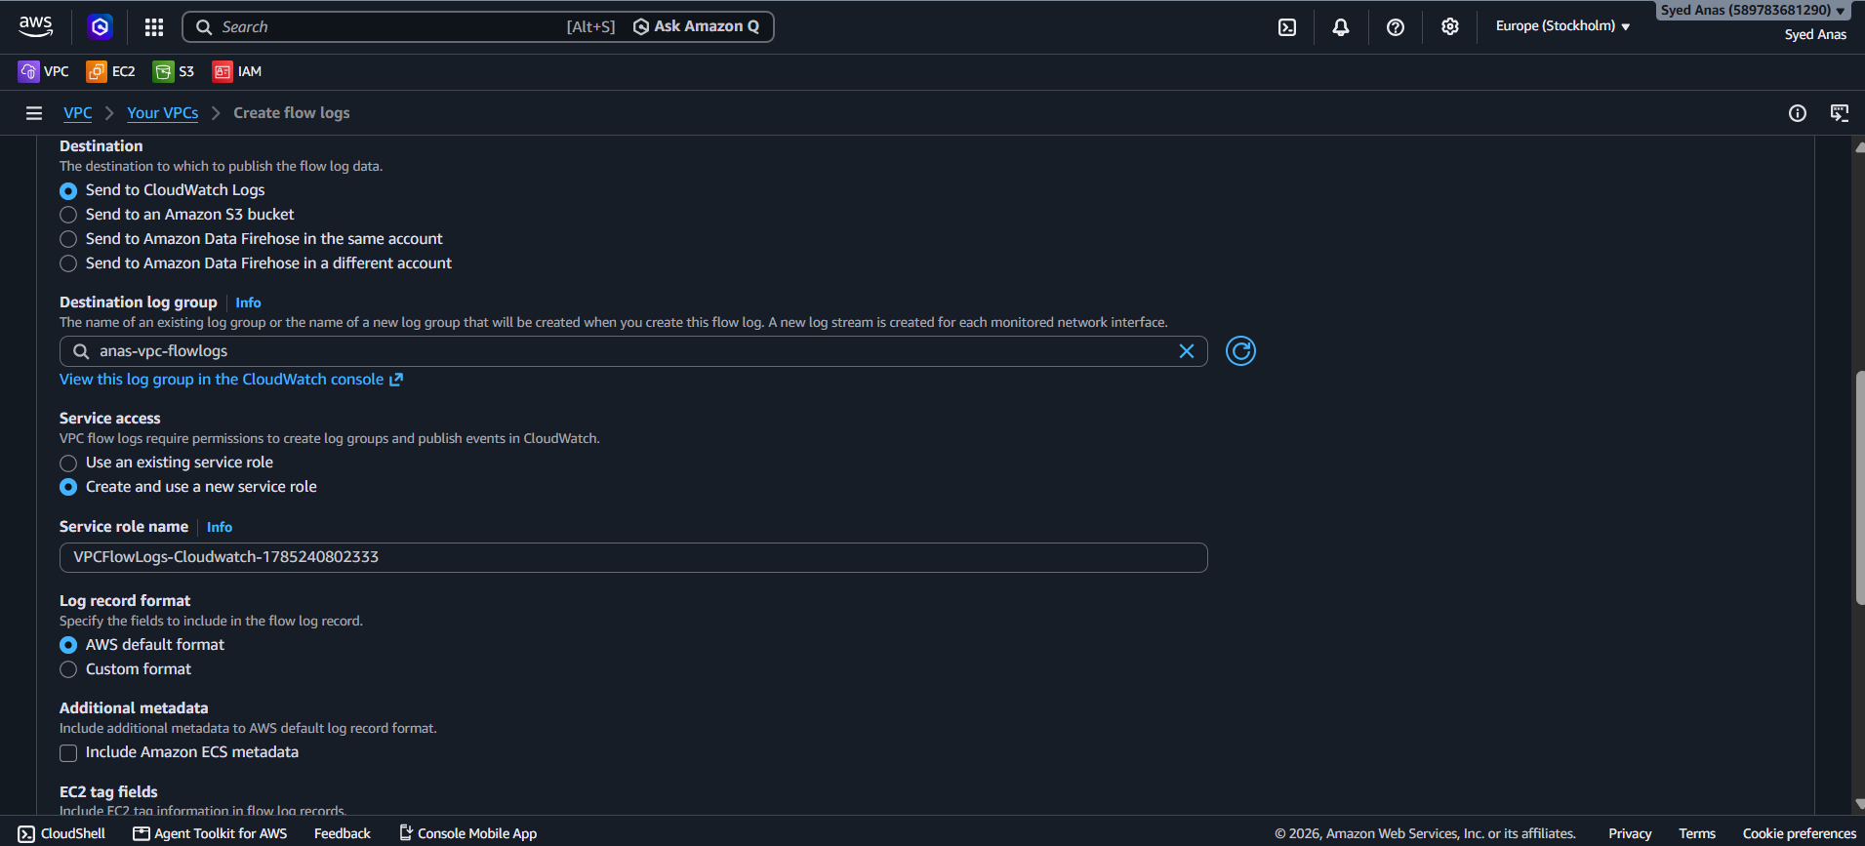

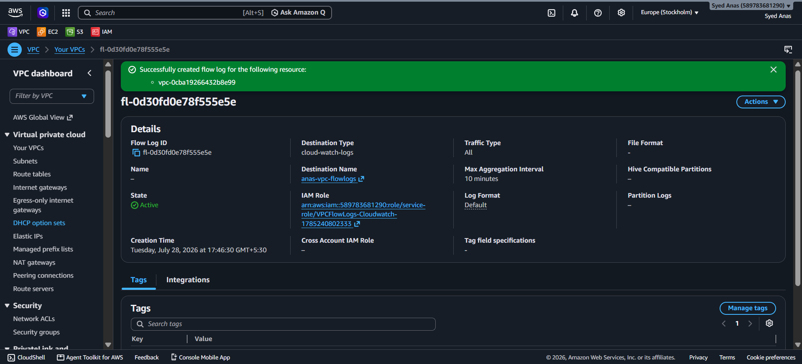

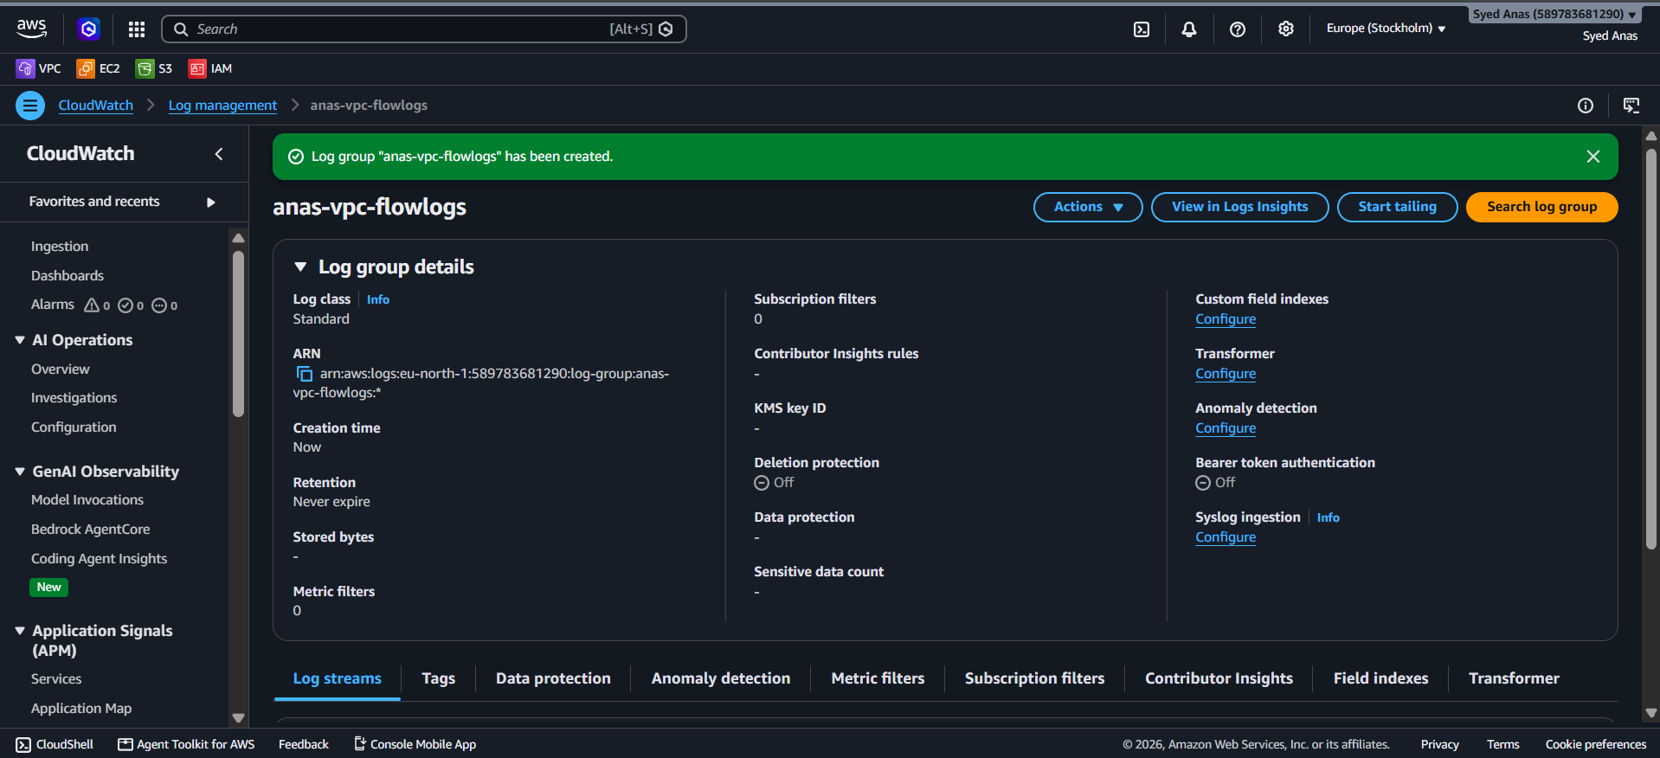

- AWS CLI:
aws ec2 create-flow-logs \
--resource-type VPC \
--resource-ids vpc-0123456789abcdef0 \
--traffic-type ALL \
--log-group-name /vpc/flowlogs \
--deliver-logs-permission-arn arn:aws:iam::123456789012:role/FlowLogsRole
Replace vpc-0123456789abcdef0 with your VPC ID and FlowLogsRole with the IAM role ARN.

Step 5: Verify Flow Logs
- Go to CloudWatch Logs → Select the log group /vpc/flowlogs.
- You should see log streams being created for the network interfaces of the VPC.
- Sample log entry:
version account-id interface-id srcaddr dstaddr srcport dstport protocol packets bytes start end action log-status
2 123456789012 eni-abc123 10.0.0.5 52.95.110.1 443 49152 6 10 2000 1609459200 1609459260 ACCEPT OK
- Explanation: Each log entry shows source IP, destination IP, ports, protocol, number of packets/bytes, and whether traffic was accepted or rejected.
Step 6: Monitoring and Usage
- You can create CloudWatch Metrics Filters on this log group to trigger alarms, e.g., detect suspicious traffic.
- Can be combined with CloudWatch Dashboards to visualize VPC traffic patterns.

- Create monitoring dashboards to monitor CPU utilization and to monitor the Apache service.
Step 1: Enable CloudWatch Monitoring for EC2
- Log in to the AWS Management Console.
- Navigate to EC2 → Instances.
- Select the EC2 instances you want to monitor.
- Ensure CloudWatch monitoring is enabled:
  - By default, basic monitoring (1-minute granularity) is enabled.
  - For more detailed metrics, enable detailed monitoring (1-minute intervals):
    - Click Actions → Monitor and troubleshoot → Enable detailed monitoring.

Step 2: Monitor CPU Utilization
- Navigate to CloudWatch → Metrics → EC2.
- Choose Per-Instance Metrics.
- Find the CPUUtilization metric for your EC2 instances.
- You can create an alarm if CPU utilization exceeds a threshold:
  - Example: CPU > 70% for 5 consecutive minutes.
  - Steps:
    - Click Create Alarm.
    - Select CPUUtilization metric.
    - Define threshold and evaluation period.
    - Set actions, e.g., send alert via SNS.

Step 3: Monitor Apache Service
CloudWatch cannot directly monitor whether a service like Apache is running. You need to publish custom metrics using a script.
3.1 Create a Script to Check Apache
- Example script for Linux (Ubuntu/CentOS):
#!/bin/bash

# Check if Apache is running
if systemctl is-active --quiet apache2; then
status=1 # 1 = running
else
status=0 # 0 = stopped
fi

# Send custom metric to CloudWatch
aws cloudwatch put-metric-data --metric-name ApacheStatus \
--namespace "CustomMetrics" --value $status --unit Count
- Save as /home/ubuntu/apache_status.sh.
- Make it executable:
chmod +x /home/ubuntu/apache_status.sh
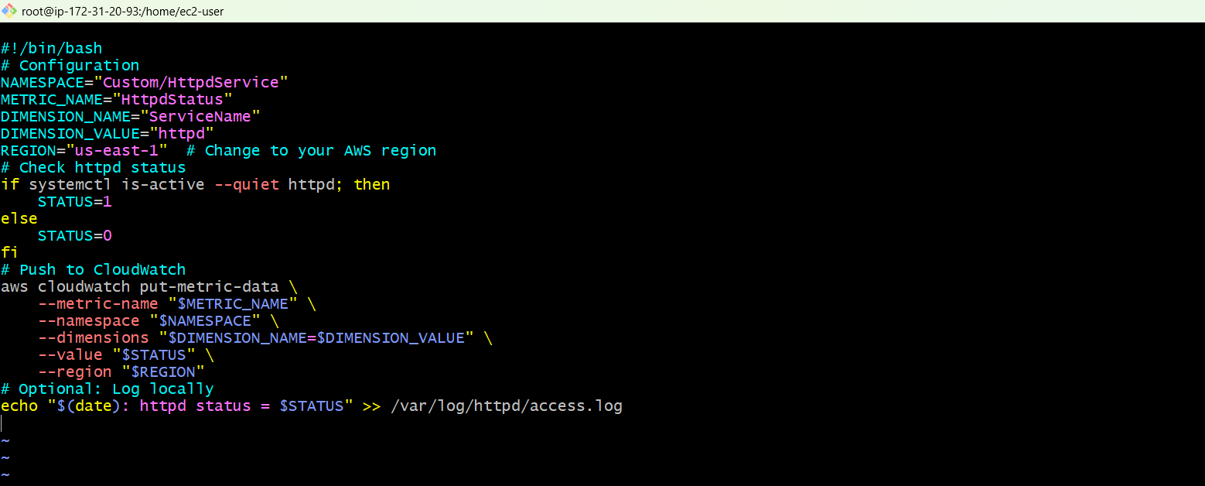
3.2 Automate Script Execution
- Use cron job to run the script every minute:
* * * * * /home/ubuntu/apache_status.sh

Step 4: Create a CloudWatch Dashboard
- Navigate to CloudWatch → Dashboards → Create Dashboard.
- Give the dashboard a name (e.g., EC2-Monitoring).
- Add widgets:
  - Line/Stacked Graph for CPUUtilization:
    - Select the EC2 instance metric.
  - Number/Status Widget for ApacheStatus:
    - Select CustomMetrics → ApacheStatus.
    - Configure thresholds: 0 = Stopped (red), 1 = Running (green).

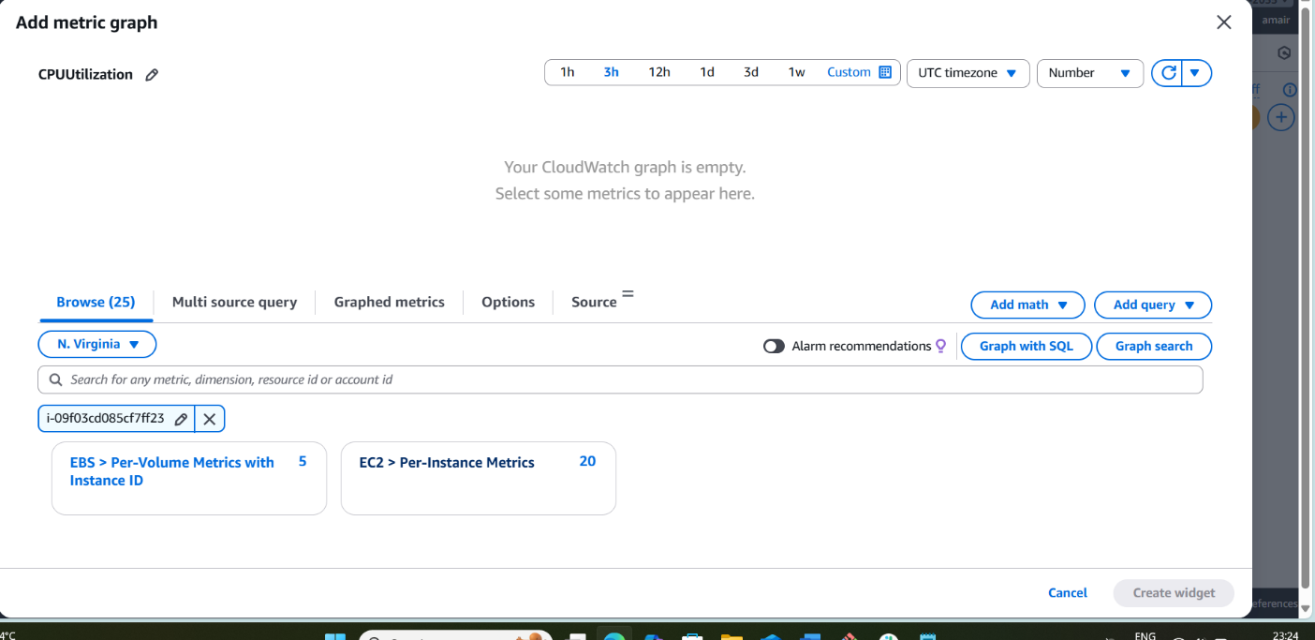

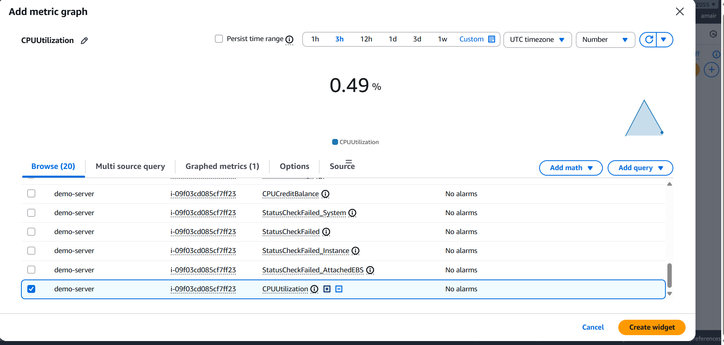

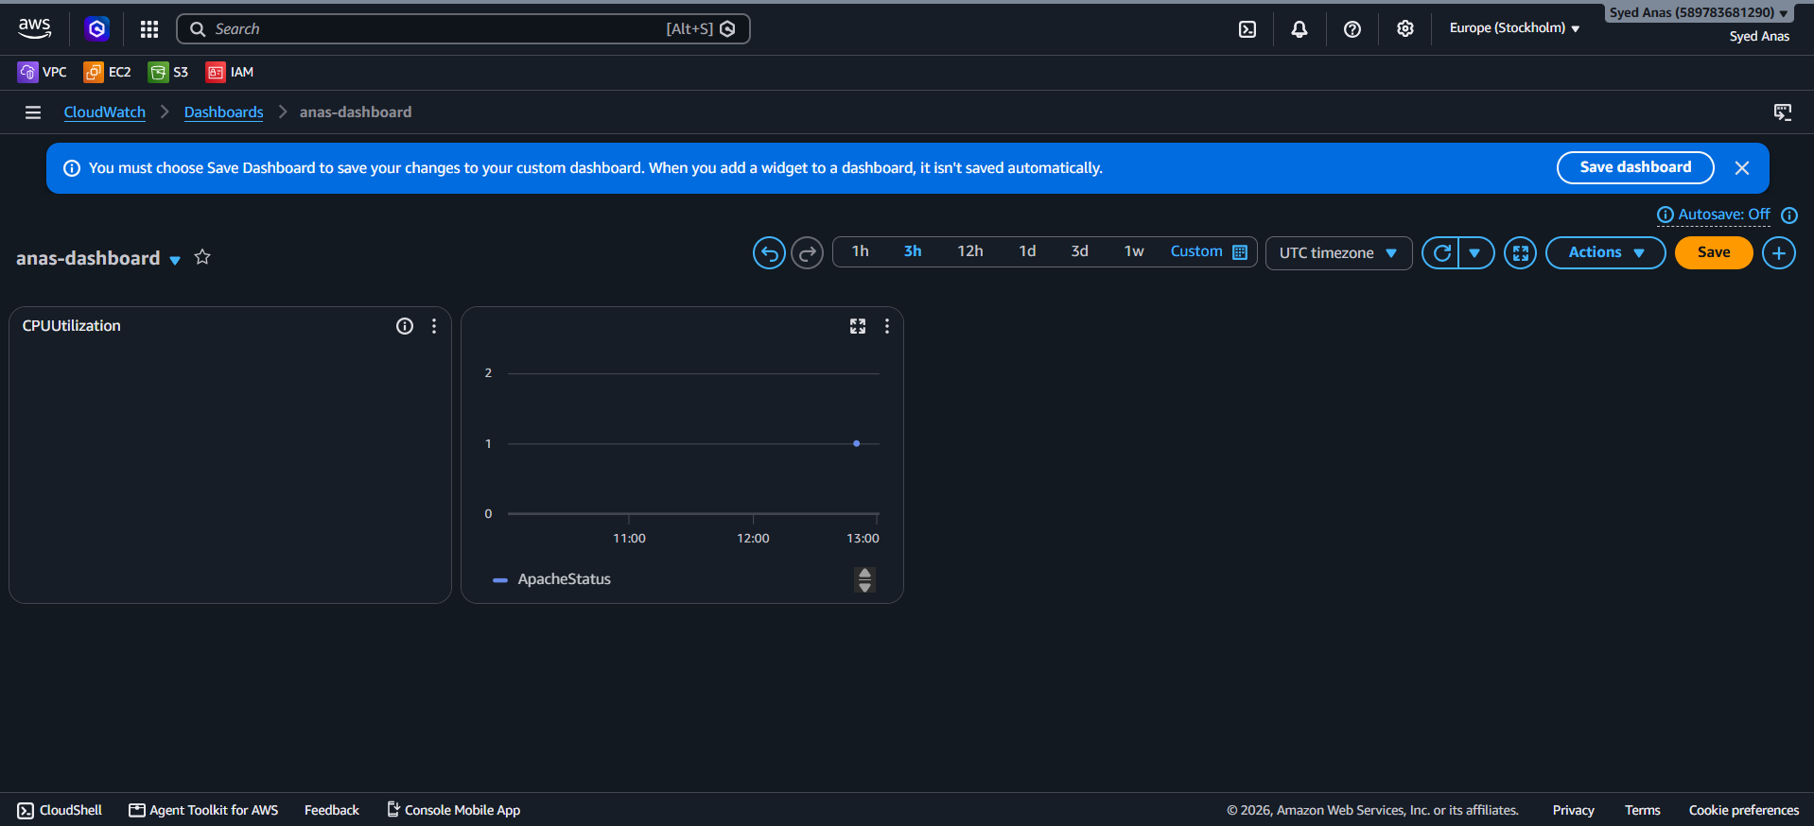
Step 5: Test and Validate
- Open the dashboard and verify:
  - CPU metrics are updating correctly.
  - ApacheStatus shows 1 when running, 0 when stopped.
- Stop Apache manually (sudo systemctl stop apache2) to verify dashboard updates to 0.

Optional Enhancements
- Alarms for Apache service:
  - Create a CloudWatch alarm if ApacheStatus = 0.
  - Trigger SNS notification to send email alerts.
- Add multiple EC2 instances to the same dashboard.
- Use CloudWatch Agent to monitor logs for Apache errors.

✅ Result
- You will have a dashboard showing:
  - Real-time CPU utilization.
  - Real-time Apache service status.
- Alerts will notify you if CPU usage is too high or if Apache stops.

12)If CPU utilization is more than 70%, then it should trigger auto scaling and launch new instance.
1. Overview
The goal is to automatically launch a new EC2 instance when CPU usage of your existing instance(s) goes above 70%. This requires:
- Monitoring the CPU usage with CloudWatch.
- Creating an Auto Scaling Group (ASG) with minimum, maximum, and desired instances.
- Setting a scaling policy to launch new instances when CPU exceeds 70%.

2. Prerequisites
Before you start, you need:
- EC2 instances running your application.
- Launch Template or Launch Configuration:
  - Contains instance type, AMI ID, security groups, key pair, etc.
- IAM role (if needed) for Auto Scaling to access resources.

Step 1 : Create a Launch Template
- Go to AWS Console → EC2 → Launch Templates → Create Launch Template.
- Fill in details:
  - Name: MyAppLaunchTemplate
  - AMI ID: (your existing instance AMI)
  - Instance Type: t2.micro (or as needed)
  - Key pair & Security group
- Save the template.

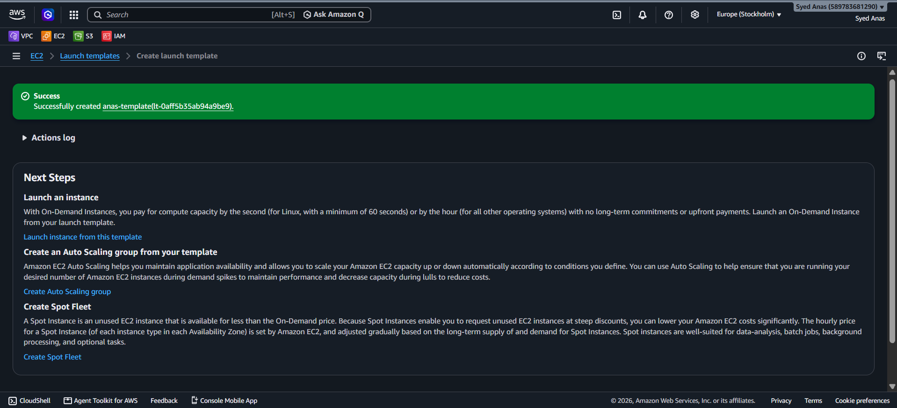
Step 2: Create an Auto Scaling Group
- Go to AWS Console → EC2 → Auto Scaling → Auto Scaling Groups → Create Auto Scaling Group.
- Select your Launch Template.
- Configure:
  - Name: MyAppASG
  - VPC and Subnets (select where instances will launch)
- Set desired capacity:
  - Minimum: 1
  - Maximum: 3 (or as needed)
  - Desired: 1
- Proceed to Next → Configure scaling policies

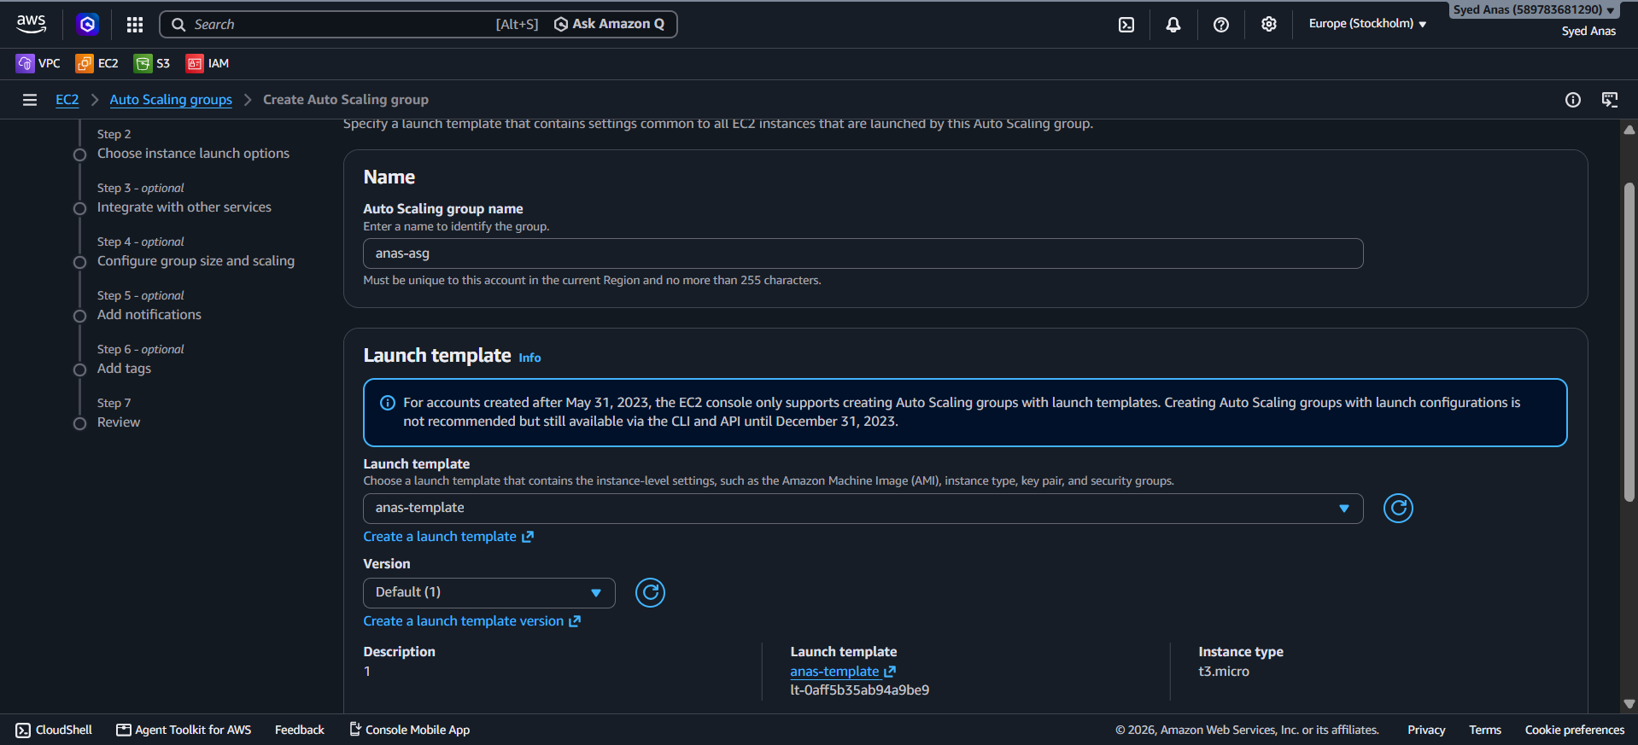
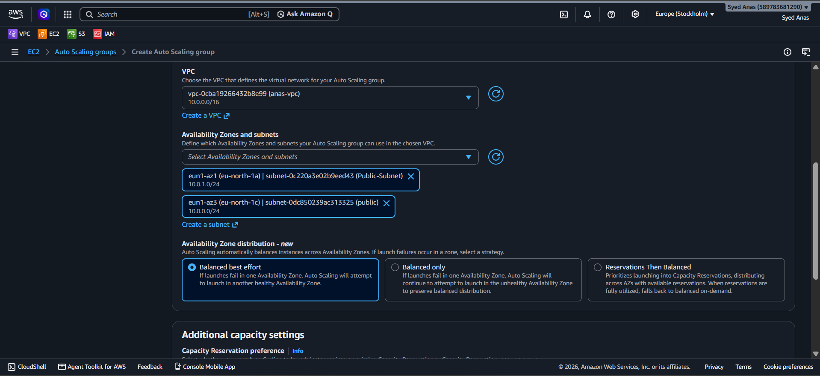
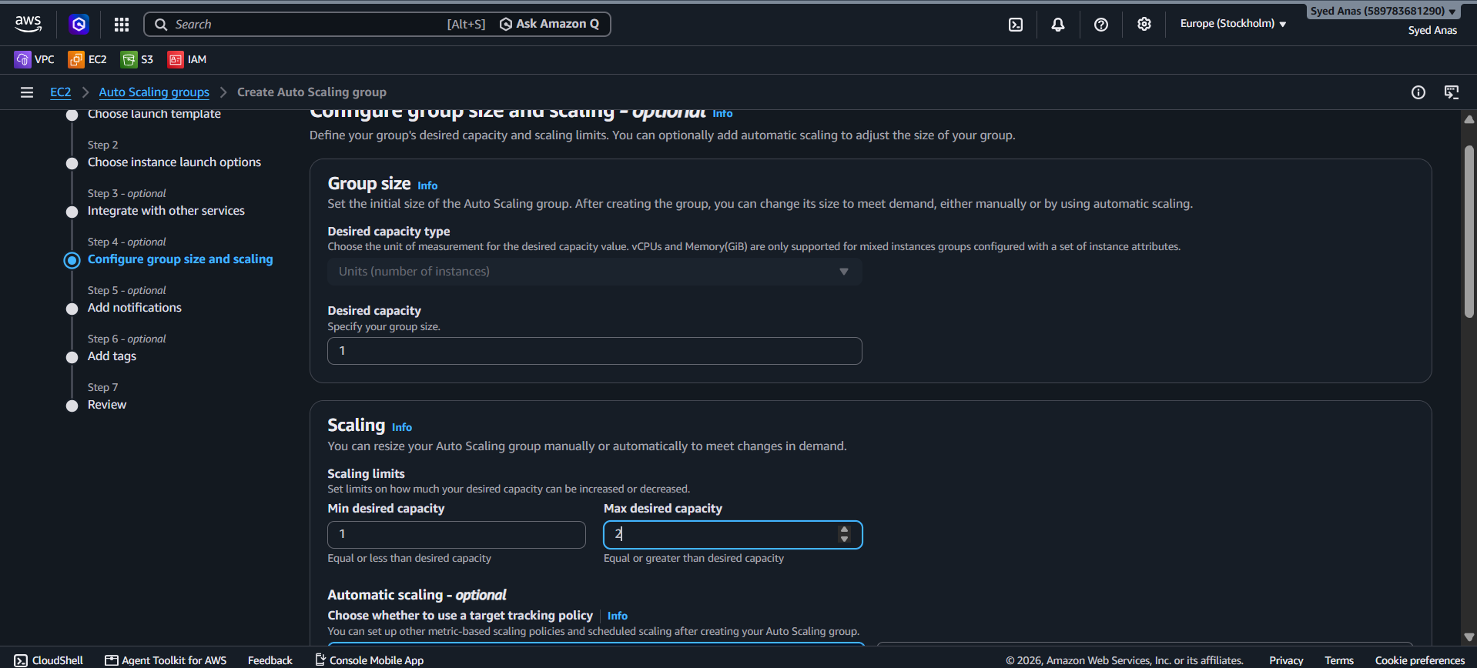
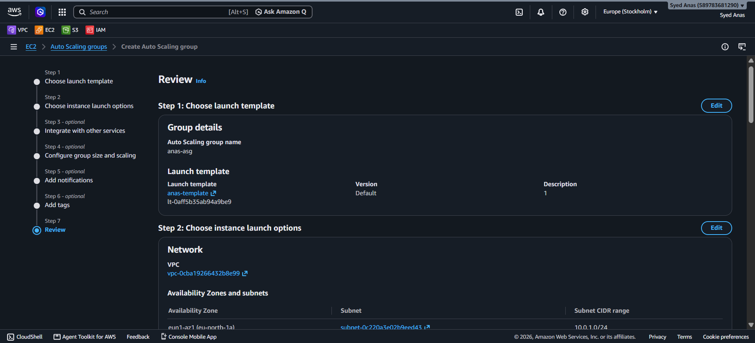
Step 3: Set Scaling Policy
- Choose Target Tracking Scaling Policy.
- Metric type: CPU Utilization
- Set target value: 70%
  - This means ASG will try to maintain average CPU around 70%.
- Review & create.
Optional: You can also use Step Scaling:
- CPU > 70% → Add 1 instance
- CPU > 85% → Add 2 instances

Step 4: Configure CloudWatch Alarm
- Go to CloudWatch → Alarms → Create Alarm.
- Select EC2 → Per-Instance Metrics → CPU Utilization.
- Threshold: > 70% for 5 minutes.
- Action: Trigger Auto Scaling policy.

Step 5: Testing
- Simulate high CPU load (e.g., stress command on Linux):
- sudo yum install -y stress
- stress --cpu 2 --timeout 600
- Monitor CloudWatch:
  - When CPU crosses 70%, ASG should launch a new instance automatically.
- Check the Auto Scaling → Instances tab to see new instances starting.

Step 6: Optional – Notifications
- Set up SNS to notify you when scaling occurs:
  - Go to CloudWatch → Alarms → Actions → Send notification → SNS topic.
  - Add your email.

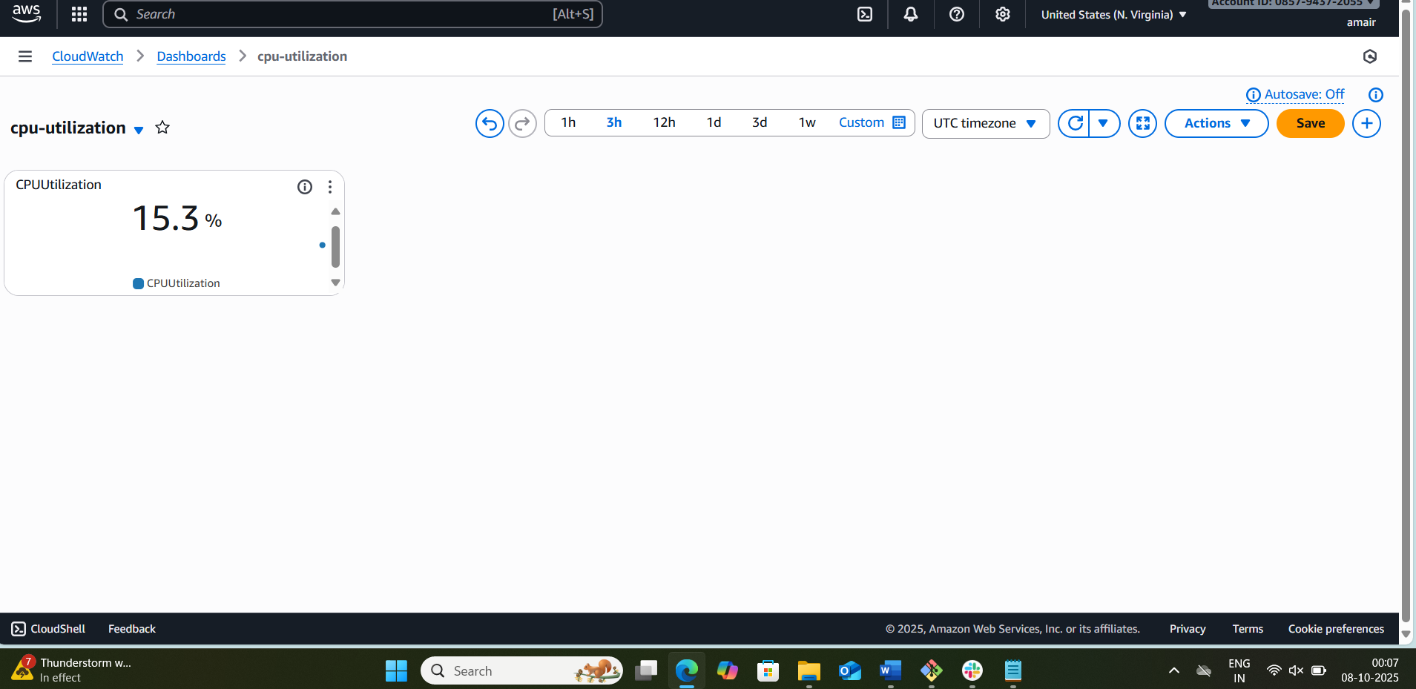
4. Summary
- Launch Template defines the instance type and config.
- Auto Scaling Group manages number of instances.
- CloudWatch alarm monitors CPU.
- Scaling Policy launches a new instance when CPU > 70%.
- Optional: SNS notifications for alerts.

✅ Result:
Whenever CPU utilization exceeds 70%, AWS will automatically launch a new instance to balance the load. If CPU drops, it can also terminate instances if desired.

